TAVERNERS
News & Review

Issue 258 – July 2011 - e-version 7

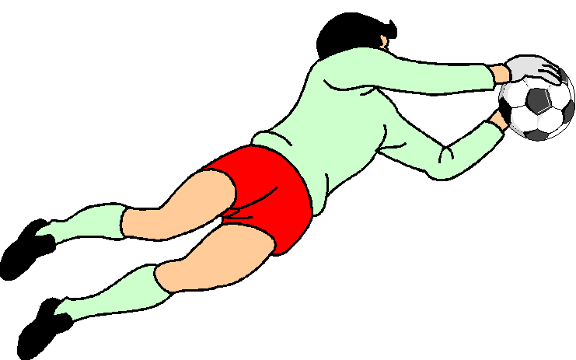

Club sponsors:


Website: www.tavernersfc.org.uk

TAVERNERS FOOTBALL CLUB

Established 1967

Members of the Ipswich Sunday Morning Football League since 1972
(Members of the Gippeswyk Sunday League 1967 - 1972)

Members of the Saul Charity Cup

Affiliated to the Suffolk County Football Association : No. GS100083

Colours:
1st team: White shirts, white shorts, black socks
2nd team: Maroon shirts, white shorts, black socks

Home ground: Greshams Sports Club, Tuddenham Rd, Ipswich

Club Committee:

Chairman: | Pat Elvin | Tel: 748206
Vice Chairman | Bill Fleming | Tel: 742713
Secretary/1st team manager: | Bob Bullamore | Tel: 729586
Treasurer: | Gary Pilkington | Tel: 01394 386686
2nd team manager | Trevor Hollinsworth | Tel: 07802176434
Officers | James Bullamore | Tel: 07917185487
 | Bevan Burgess | Tel: 612693
 | Daren Stevens | Tel: 07979851887
 | Tom Brooks | Tel: 740868
 | Duncan Southgate | Tel: 07834614677

Club honours:

1st team: | Winners | Ipswich SML Division 2 | 1993/94
 | Winners | Fairplay - Division 2 | 2001/02
 | Winners | Fairplay - Premier Div. | 2003/04
 | Runners-up | Ipswich SML Division 1 | 2004/05
 | Winners | Fairplay - Premier Div. | 2005/06
2nd team | Winners | Ipswich SML Reserve Cup | 1994/95
 | Winners | Fairplay - Division 5 | 2001/02
 | Winners | Fairplay - Div. RM 1 | 2009/10
 | Runners-up | Ipswich SML Division 7 | 1985/86
 | Runners-up | Ipswich SML Division 5 | 1987/88
 | Runners-up | Ipswich SML Reserve Cup | 1992/93
 | Runners-up | Ipswich SML Reserve Cup | 2002/03
 | Runners-up | Ipswich SML Reserve Cup | 2003/04
Club | Runners-up | Suffolk FA Fairplay Award | 2000/01

Taverners
News & Review

Issue no. 258 – 17 July 2011

Looking back with the Tavs
….from 5 to 40 years

5 years ago (January 2006)……The first team were
disappointed to be beaten 2-1 by Holbrook Rovers
(Jason Riley scoring) but bounced back with a
tremendous performance which earned a great 2- away win over Belstead Arms. A Daren Stevens header and a Kevin ‘Moggy’ Morrison spot-kick scored our goals.

However, we were blasted out of the Senior Cup 5-2 by Kings Head. ‘Moggy’ and trevor Hollinsworth scored the Tavs goals.

The reserves bowed out of the Sunday Shield against Kelsale SC 5-3 after extra time; the scores were level at 3-3 after 90 minutes, the Tavs having fought back from a 3-1 deficit with goals from Vaughn Gledhill, Mike Cura and Tim Atabaky.

A fine effort on a heavy pitch although the result was disappointing.

The reserve team showed more fighting spirit in a goalless draw against Colonials but were then beaten 1-0 by Murray Rangers.

10 years ago (January 2001)……The first team began the New Year with a boost in their battle against relegation. Our record against St Clements had been dreadful previously and this looked set to continue with the Saints leading 2-0 with 20 minutes left to play.
But, as the Taverners News & Review of the day reported: “…..we had a lifeline when James Bullamore’s cross was handled and Andy Spivey scored from the spot. Some fine play from Bevan Burgess then put Richard Fuller through to beat the advancing keeper for the equaliser.”

We then secured another great point in a 2-2 draw away to Melton YCOB. With the score at half-time goalless, we grabbed the lead through a Gary Pilkington header. Melton took advantage of the slope to score twice but the Tavs fought back and a header from Andy Glover gained a vital point.

The reserves struggled to put much football together on their visit to Yoxford Wanderers and had the double misfortune of seeing a penalty award reversed to a free-kick outside the box and then conceding a dubious spot-kick themselves.

Our concentration was affected but we eventually gained a point when Duncan Southgate broke into the box and his low cross was swept in by Gary Pilkington.

We then relied on a late winner from Duncan Southgate to beat Melton YCOB reserves after the teams had been deadlocked at 2-2. Our earlier goals were both fine efforts from Tom Parker.

The reserves were then knocked out of the reserve Cup in a quarter final tie by Norbridge reserves. Gary Pilkington scored the Tavs goal on a morning when we lacked the passion and commitment for a cup game.

15 years ago (January 1996)……The first team was pushed deep into relegation trouble by a 2-1 home defeat by Dickerson. Gary Cunningham scored the Taverners goal.

Once again, Blue Circle at Great Blakenham was an unhappy venue for Taverners as we were beaten 6-2 by Stow Vandals. Matt Morling scored both our goals.

The reserves began the New Year with a 5-1 reverse at home to Hollesley United, the Tavs goal coming from Matt Morling. The reserves were drawing 1-1 with The lion (at home) when a late goal from Matt Morling seemed to have won us the points. However, an own goal in the dying moments grabbed a point for The lion. Duncan Southgate had scored the first Taverners’ goal.

The reserves then visited a Guardian side managed by Steve Godden and a ‘battle royal’ ensued. The Guardian eventually won 3-2, the Tavs goals coming from Mike Ray and Bevan Burgess.

The reserve team’s hold on the Reserve Cup they had won the previous year came to a dramatic end in a home quarter final tie against Blakenham Chequers reserves. Blakenham held the lead until late in the game when the Tavs grabbed an equaliser with an effort from James Bullamore, wide on the right, which flew over the keeper. Extra time seemed a certainty until Blakenham broke away to score a late winner.

20 years ago (January 1991)…..The first team’s high hopes of promotion from Division 2 of the (then) SHE League faltered again with a 2-1 defeat away to Suffolk Punch, the winning goal coming in the final minute. Kevin Oxborrow had scored the Taverners goal. This poor sequence of results continued with a 3-1 reverse against Gotham, again at Whitton Sports Centre. Andy Spivey scored our goal with a penalty after Gary Cunningham had been fouled. Andy also hit the bar when we were 2-1 behind. However, Gotham scored their vital third goal as we pressed forward in search of an equaliser.

Our League Senior Cup run came to an end at the quarter final stage when we were beaten 4-1 by Stow Vandals at Cranes The score certainly didn’t flatter the Tavs as we battled well throughout. Gary Cunningham scored our goal.

The reserves were beaten 3-0 at home by BT Research but then took a point in a 2-2 draw with old rivals Armada reserves. Craig Sherwood scored our goal.

The reserves were beaten 3-0 at home by BT Research but then took a point in a 2-2 draw with old rivals Armada reserves. Craig Sherwood scored both the Tavs goals.

We then pulled off a great result, beating leading side Premier Pool by 6-1. Jamie Needham led the scoring list with four goals and our other scorers were Craig Sherwood and Justin Peartree.

25 years ago (January 1986)….. The first team began the New Year with a 0-0 draw against an improved Cranes at Gainsborough. Both teams had chances to win, Taverners being thankful for a headed goal-line clearance by Terry Pilbro. Our promotion hopes took a knock with a 2-1 defeat away to Debenham in a very physical encounter. Elwyn Scored the Tavs goal.

We returned to winning ways with a 2-0 victory over Claydon, although our task was made more difficult by the unfortunate dismissal of Terry Pilbro just before half-time. Terry subsequently won his appeal against the sending-off at a disciplinary hearing. The Taverners goals were scored by Chris Lushington.

Taverners reserves strode into 1986 with a 5-0 victory over Bucklesham Wanderers, the goals coming from Andy Glover, Stuart Webb 2, Gary Cunningham and Chris Voller. We followed this up with another emphatic win against Sutton United, our marksmen in a 5-1 scoreline being Danny Blackman 3 and Andy Glover 2.

Unfortunately, a surprise defeat at the hands of Orford Town was to follow, the scoreline being 2-0.

30 years ago (January 1981)……The seniors scored a heartening win over Italia Unita at Bourne Park, our scorers in a 6-2 scoreline being Mick Flude 3, Pat Elvin 2 and Glen Parker while Colin Dawson made a penalty save at a vital stage.

We gave a great deal of effort against Belle Vue Aces on a heavy King George V pitch but were beaten by a 6-1 scoreline which flattered our opponents. Mick Flude scored the Taverners goal.
As usual over the years, our match against Rampant Horse was a tough encounter with our opponents seeming more resolute after having one of their number sent off late in the first half. They were finally beaten when Mick Flude fired home from the edge of the box ten minutes from time. The month ended with a 0-0 draw away to second-placed PO Research.

The reserves began the year with an extraordinary match against EEB. With 30 minutes left, we trailed 5-1 and, as the 90 minute mark approached, we were 6-4 behind. However, the Tavs managed to grab a point in a 6-6 final scoreline. Our scorers were Bill Ormsby 3, Neil Bennett 2 and Chris Lushington.

Unfortunately, we were then blasted out of the Reserve Cup by Stowmarket Athletic reserves by 11-2. Our goals came from Neil Bennett and Bill Ormsby.

The reserves were on the losing end of a 3-2 scoreline a week later against Armada reserves. Bill ormsby and Brian Palmer were the scorers. We finished the month in style, beating Ipswich rangers by 7-0. Brian Palmer led the way with four goals followed by Steve Baker 2 and Bill Ormsby.

35 years ago (January 1976).....Our first game in 1976 was a taste of things to come as we slumped to a 6-0 defeat at the hands of Chantry YC on a heavy Ellenbrook Green pitch. We were also unfortunate to lose gallant goalkeeper Derek Nunn through injury.

We then suffered a 4-2 defeat against Manor House, our goals coming from Mick Flude and Paul Miller, before ending the month with a 3-1 reverse against Holbrook Rovers. Paul Miller scored the Taverners goal.

40 years ago (January 1971)……Taverners bounced back after their defeat at the hands of Harris Sports reserves with a solid display which saw Capel St Mary beaten 2-0 in a Gippeswyk League Division 3 game at Woolverstone. Russell Langham and Ross Turtill scored the Taverners goals.

We then visited Supply at Bader Close (another of the now-defunct grounds scattered around the town - in those days hosting Senior football on Saturdays). A 3-1 boosted our rise up the table, our goals coming from Mick Johnson, Martin Buck and an own goal. January was rounded off with a 4-2 home victory over Dagenham YC, our scorers being Martin Buck, Russell Langham and Mick Johnson.
More Looking back with the Tavs .... from 5 to 40 years

5 years ago (February 2006)………The first team only played one match during the month, losing
4-1 to GA McGintys. Lee Riley scored his first goal for the club.

The reserves were beaten 3-1 by Pauls (Sam Vincent netting for Taverners) and the Tavs News & Review of the day reported that “the Ipswich supporters amongst us had our spirits revived as we watched the Town beat the Canaries in style on Sky”.......those were the days!

A 4-1 home defeat for the reserves at home to Orford Town (Simon Fisher scoring) was followed by a confidence-sapping 8-1 reverse at the hands of Fat Cat; Mike Curs scored for the Tavs.

The month ended with a 2-0 Reserve Cup exit at the hands of Rushmere CFC reserves.

10 years ago (February 2001)………The first team only played one game during the month, a most disappointing morning ending in a 3-1 defeat at the hands of Forum Pool after we had taken the lead through a superb effort from Gary Cunningham.

The reserves travelled to Stow Pickerel with the bare eleven but produced a battling performance which merited more than a 5-1 defeat. Ray Sherman scored the Tavs goal.

A disappointing month ended with a 2-1 defeat at home to Worlingworth after great efforts had been made to clear the lines at a snow-covered Greshams. Gary Pilkington scored the Tavs goal, heading in a Carl Brame free-kick.

15 years ago (February 1996)……..Our battle against relegation from Division 1 (now Premier) continued with a heavy defeat - 8-2 - at the hands of Stow Vandals. Our scorers were Paul Oakshott and an own goal. The month continued in a similarly depressing vein, the Tavs being beaten 3-1 away to Melton YCOB (Gary Cunningham our scorer), 4-1 at home to Chars field (Mike Cura on target) and 5-0 at home to Heathfield.

The reserves produced a fine performance to beat Ipswich telephone Engineers 4-0, the Taverners goals coming from Mike Ray 3 and Duncan Southgate and followed this with a 4-1 win away to Aldridges. Our scorers were Mark ‘Bubble’ Smith and Toby Cousins 2. Walton Feathers were then beaten away by 3-0 (Toby Cousins 2 and Bevan Burgess scoring) before a tremendous month ended with a 6-0 home win against Wetherden Wanderers. Matt Morling 2, Mike Ray 2, warren Page and Duncan Southgate scored for the Tavs.

20 years ago (February 1991)…………. The first team emerged from a wintry spell of weather and a dreadful run of results to beat Felixstowe Dock by 4-1 at Cranes, the scorers being Gary Cunningham (with a first half hat-trick) and Terry Pilbro. We looked to have won our next game, away to RSSC Dales, when Simon Finch scored midway through the second half but Dales fought back to score a late equaliser and Tavs keeper Mark Moore had to be at his best in the dying minutes to retain a point.

The reserves had to produce a great fight-back to rescue a point against JTB in a final 1-3 scoreline. JTB had led 3-1. The Taverners goals came from Daren Stevens, Craig Sherwood and Steve Martin. A visit to RAF Wattisham ended in a disappointing 3-1 defeat, Jamie Needham scoring the Tavs consolation.

25 years ago (February 1981)……..The senior eleven’s promotion hopes were dented when they were beaten 1-0 at home by an unfancied 405. However, we returned to form to gain a point from a tough game against Felixstowe Spartans at a bleak Eastward Ho ground. Spartans had Neil Bennett in their ranks and he and the Tavs’ Pat Elvin still talk over their 90 minute midfield battle!

Terry Pilbro twice gave Taverners the lead but on both occasions the Spartans fought back to equalise.

Unfortunately, the team contrived another poor performance at home to relegation-haunted McDougall Rose and were beaten 2-1 to once again raise doubts about our promotion challenge. Terry Pilbro scored the Taverners goal.

The reserves began the month by entertaining fellow-promotion contenders St Margarets and a well-contested game finished all-square at 1-1, Tavs’ debutant Simon Ayers scoring. The team then established an all-time Taverners scoring record by beating East End by 12-0 at Gippeswyk Park, the goals coming from Simon Ayers 5, Stuart Webb 2, Ian Green 2, Chris Voller, Danny Blackman and Gary Cunningham.

30 years ago (February 1981)…….The Tavs kicked off with a 3-1 win over John Player reserves - always competitive opponents - with Mick Flude netting a hat-trick, including one direct from a corner.

A frozen pitch at Barking Tye caused the Tavs’ game against Gipping to be postponed a week later. We returned later in the season to win the re-arranged game, ironically in very heavy conditions.

We then drew with Northam Celtic 1-1 at Bourne Park and, after Pat Elvin’s early goal had been cancelled out, we were grateful for Colin Dawson’s fine efforts to help us hang onto a point.

A promising run was brought to an abrupt halt a week later when we were beaten 6-0 by Stowmarket Athletic reserves, five of the goals coming in a 12 minute spell at the start of the second half.

The reserves had to fight back from an early deficit against Rebels and finally won 5-1 with goals from Bill Ormsby 2, Ian Scott 2 and Brian Palmer. Another come-back was needed a week later against Sutton Plough and again Taverners ran out eventual winners, this time by 6-2. Ian Scott, Bill Ormsby, Brian Palmer, Steve Baker and Chris Lushington scored the goals.

Defences were very much on top the following week when the reserves met Lions Head, the teams finishing at 1-1. Steve Baker scored the Tavs goal. The second eleven produced a performance thought by many to have been their best up to that time - a 6-4 win over the long-unbeaten Sproughton Wild Man.

Bill Ormsby led the way with four goals - thereby scoring his seventh hat-trick of the season for the Club; a record which is still unbeaten. Our other scorers were Steve Baker and Neil Bennett.

35 years ago (February 1976)……. Taverners continued their poor Division 6 run with a devastating 10-2 defeat at the hands of Magpies on a frosty Gippeswyk Park pitch. John Davey and Paul Miller scored for the Tavs.

We then faced Magpies in the return and, in heavy conditions, regained some respect in a 0-2 defeat before finding real form with a ‘coupon-busting’ win away to Coastal Wanderers (now Orford Town) by 6-3.

The goals came from Paul Miller 2, Colin Last 2, Pat Elvin and a young Micky Parker.

We rounded off the month with another good result, a 4-2 victory over Kesgrave at Bourne Park with goals from Paul Miller, John Davey, Colin Last and Mick Flude.

40 years ago (February 1971)…..We began by reversing a recent defeat at the hands of Harris Sports reserves by beating them 2-0 at Chantry Park with goals from Ross Turtill and Russell Langham.

The Tavs then beat Kirton 4-0 at Woolverstone with Russell Langham - who had developed into a fine centre forward - scoring a hat-trick and receiving attention from the local press. Our other scorer was live-wire winger Adrian Dickerson.

Games against Italia Unita were always full of atmosphere - both on and off the pitch - and we enjoyed our visit to their home ground at Bourne Park by winning 3-1.

Our scorers were Adrian Dickerson, Russell Langham and Martin Buck.

‘Keeping in touch’
This is our seventh ‘e-version’ News & Review and, although we are happy to produce a ‘hard copy’ for those who prefer it, distributing each edition electronically has proved cost-effective – with fewer rainforests at risk!
In addition to our current members, we have built up a data-base of ex-players and supporters who we hope enjoy keeping in touch – many, of course, will look for mentions in the ‘Looking Back’ features!
If you know of anyone who might be interested in receiving future copies, do let Bob know; all we need is an email address.
For completely up-to-date detail – with photos and weekly updated statistics & reports – do visit the club’s website:
www.tavernersfc.org.uk
The website also includes archived issues of the News & Review.

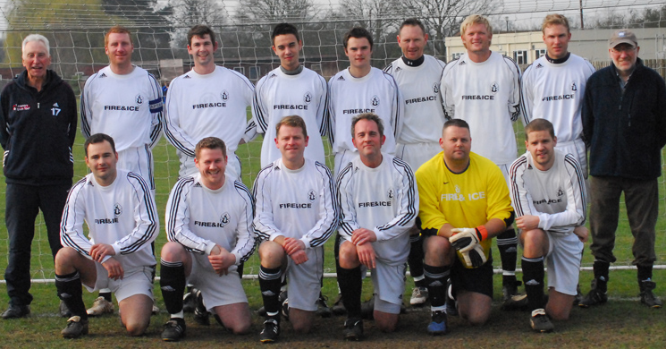

The 1st team meet the camera:
Back: Pat Elvin (chairman), James Bullamore, Ryan Horsfall, Jamie Brittain, Matty Wray, Andy Lambert, Ben Norfolk, Tom Brooks, Bob Bullamore (manager).
Front: Eamon Mongan, Adam Beaney, Gary Pilkington, Matt Davis, Clive Halls, Philip Bowman

First team focus - Bob Bullamore reports
We surely deserved better........................................................Taverners 0 Ransomes Sports 2
Meeting Ransomes Sports for the third time this season - and with a team showing six changes - the Tavs began solidly and, although Ransomes had slightly more of the play, we tackled hard and played some good football on the counter-attack. It was good to see Ben Norfolk back in a Taverners shirt after his spell 'down under.'
Tom Brooks was tenacious while Eamon Mongan did well on the left side. Unfortunately, our problem remains in the final third although Ransomes were also unable to score before the break, mainly because of good defensive work and several good saves by Clive Halls.
The confidence we had built up in the first half was dented by a well-taken Ransomes goal early in the second half but we regained our rhythm and pressed forward. On another day, Tom Brooks could have had a hat-trick but he had no luck with his finishing - one header well saved and other efforts going close. A loud appeal for handball in the box went unheaded while Ryan Horsfall - keen to get forward at every opportunity -was tripped in a dangerous position.
As a scramble deep in the Ransomes six yard box was cleared it was looking evident that we weren't destined to score and we were caught on the break in the dying moments as Ransomes went through for a second goal.
Team: Halls, Beaney, Bullamore, Lambert, Wray, Brittain, Brooks, R Horsfall, Mongan, Norfolk (Sub: Bowman), Pilkington (Sub: Hollinsworth).
Excellent from the Tavs...........................................................................................Underwoods 1 Taverners 1
Despite having to make several changes, the Tavs began with great confidence, playing some good football on the big Dellwood Avenue pitch. Our spirits were boosted by an early goal - Duncan Southgate's superb free-kick being mishandled by the Underwood keeper and Gary Pilkington pouncing to drive the ball home.
Underwoods came forward and we had one let-off when our offside trap failed while Clive Halls tipped another effort over the bar. We were battling for everything all over the pitch with Andy Lambert and James Bullamore marshalling the defence well.
We were still looking dangerous in attack and we were disappointed that an apparent foul on Daren Stevens as he bore down on goal wasn't punished while one tremendous goalmouth scramble saw three Taverners' efforts blocked.
The second half saw Underwoods enjoy an increasing amount of possession but our tremendous workrate continued - with Tom Brooks celebrating his 200th appearance for the club with a whole-hearted and determined display.
Underwoods took advantage of a mistake to equalise and the pattern of the game changed with a double-dismissal, Matty Wray being the Tavs player involved.
We kept our heads and team-shape, however, to hold out for a fully deserved point.
Team: Halls, Beaney, Lambert, Bullamore, Burgess, Southgate, Horsfall, Brooks, Wray, Pilkington, Stevens

Our opponents shade it......................................................................................Taverners 0, Underwoods 1
Considering that the two team met a week ago - when a player from each side was dismissed - the first team's game against Underwoods was an excellent advert for Sunday football; hard-fought but played in good spirit and well refereed by Gavin Hetherington.
The teams had respect for each other after last Sunday's draw and there were not too many clear-cut chances although Andy Lambert produced one marvellous clearance off the line and Bevan Burgess another while, at the other end, Henry Chard looked dangerous breaking on the right hand side. We had an excellent last twenty minutes of the first half, putting on pressure but unable to break through.
As the second half progressed, it looked clear that one goal would win the match. Andy Lambert again blocked on the line while our closest efforts were a Tom Brooks shot which was tipped over and a shot from Daren Stevens which just cleared the bar.
Eventually, it was Underwoods who went ahead after a good run through by one of their defenders and, although we had plenty of possession, we rarely looked like equalising.
Team: Halls, Beaney (Sub: Brittain), Bullamore, Lambert, Burgess, Chard, Brooks, R Horsfall, Wray, Pilkington (Sub: Norfolk), Stevens.

So near and yet...............................................................................................Taverners 1, Capel Plough 2
A real six-pointer, this one! The last two weeks have seen the Tavs play some good football without showing enough thrust or guile to pose much threat to the opposition and against Capel Plough we had an outstanding opening 20 minutes but were unable to score while Capel looked dangerous in breakaways and might have gone ahead more than once.
Eventually, a defensive mistake let Capel in and our woes were increased when a penalty enabled them to make the score 2-0.
However, we battled on and eventually pulled a goal back when the so-busy Tom Brooks headed on, Henry Chard produced the pass and Ben Norfolk chipped the ball over the advancing goalkeeper.
Now we were back in it and a succession of crosses, long throws and corners produced lively goalmouth action without a situation developing where we managed a clear sight of goal.
Overall, the result turned on decisions in the two penalty areas. We felt very aggrieved to see a penalty awarded against us, with the grounded Andy Lambert still adamant afterwards that any contact with the ball was purely accidental, while, at the other end, our loud appeals for hand-ball and a spot-kick were turned down.
In a goalkeeping crisis, we were grateful to Daren Stevens for donning the gloves and he did well.
Team: Stevens, Beaney, Bullamore (Sub: T Vincent), Lambert, Burgess, Southgate, R Horsfall, Brooks, Wray, Norfolk, Chard

Oh dear!........................................................................................Taverners 0 Belstead Arms 12 (Twelve)
Everyone concerned will be relieved at a brief report of one of the club's worst-ever defeats.
If Belstead Arms were able to field the side that faced us every week then they would have a great chance of winning the league.
Without hiding behind excuses, we were somewhat weakened and had no answer to some speedy and incisive attacking.
A word for Matt Davis who had no chance with any of the goals and continued to tackle his job in the 90th minute with the same enthusiasm as he had at the first whistle.
We must, as a club, look forward and give long consideration to how the recurring 'numbers problem' can best be tackled in the future.
Team: Davis, Beaney, Bullamore, Leeks, Burgess, Aldred, Brooks, R Horsfall, Wray, Cunningham, Stevens.
Pilky’s illness overshadows all else....................................................Holbrook Swan 3, Taverners 0
The first team's visit to Holbrook to face the Swan was completely overshadowed by the illness which befell Gary Pilkington so suddenly. Our best wishes are with Pilky and his family.
Those who made up the Tavs scratch team could feel proud of their efforts in battling for 90 minutes and letting nobody down at all. It would be unfair to mention individuals because everyone played their part in full.
Team: Gledhill, Beaney, Lambert, Bullamore (Holmes), Cunningham, Atabaky, Pilkington (Hollinsworth), Chapman, Burgess, Aldred, Wray.
Thistle look champion...........................................................Taverners 0, Ipswich Thistle 5
The curtain finally came down on a highly disappointing season for the Tavs with a home match against Ipswich Thistle who needed the points to cement their title challenge.
An early Thistle goal set the alarm bells ringing but the Tavs fought very hard for the rest of the first half, only to concede two more just before half-time.
Thankfully, we managed to raise our spirits after the break and restricted the Thistle to two more goals. Andy Lambert shone while Tom Brooks and Matty Wray's efforts were tireless in midfield. Our last line of defence, Vaughn Gledhill produced a string of fine saves.
Thistle went on to win the Premier League championship and we congratulate them for a fine and well-deserved achievement.
We were pleased to have a full compliment of substitutes and thank particularly Trev and Julien who didn't see any action.
Team: Gledhill, Beaney, Bullamore (Sub: Atabaky), Lambert, Burgess, Fisk (Sub: Aldred), Brittain (Sub: Chapman), Brooks, Wray, Stevens, Cox.

Reserve Scene - Trevor Hollinsworth reports
A morale-boosting win.....................................................Taverners reserves 3, Felixstowe Harpers reserves 2
Sunday football gets very little praise and acknowledgement so it's good to report the reserve team's home game against Felixstowe Harpers reserves which was a hard-fought but entirely sporting contest, well refereed by Tony Joyce and with the result in doubt up to the final whistle; enjoyable to play in and watch.
The first half saw the Tavs pressing forward and playing some good football with Matty Wray - energy itself - involved in attacks and in tackling back when required. We took the lead when Daren Stevens won the ball at the far post and headed down for Eamon Mongan to fire home.
Trevor Hollinsworth was thwarted by the keeper as he followed up a mishandled shot and then Eamon saw a similar effort blocked close to the Harpers goal. As so often happens, a breakaway spelt danger and Harpers went through to equalise before half-time.
The early part of the second period saw Taverners well on top and we eventually regained the advantage when Trevor was played in and he waited till the ball was 'in his stride' before shooting home. Trevor had earlier seen a good effort go narrowly wide.
A corner from Trevor led to our third goal. In fact, an eagle-eyed Frank confirmed that the corner had crossed the line (unseen by the referee) for a goal before the goalkeeper clawed it away but Harpers' relief was short-lived as Bevan Burgess pounced to drive the ball home for a 3-1 lead.
Several half-chances on the edge of the box went narrowly wide or over as Taverners threatened to run away with the game. However, indecision gave Harpers the chance to score a second and we were on tenterhooks during the dying minutes as some resolute defending was needed for the Tavs to retain the lead.
Team: Smith A, Davis (Baxter), Lambert, Leeks, Cunningham, Burrows, Wray, Mongan, Burgess, Stevens, Hollinsworth

Tavs lack punch......................................................................Taverners reserves 0, Holbrook Swan reserves 1
Holbrook began on top but very poor finishing meant that they never pushed home their advantage.
We suffered two blows - Paul Ryan being injured after 20 minutes play and the Sam Burrows being sent off after a scuffle. The Holbrook player involved escaped with a booking which cannot be explained.
Holbrook finally took the lead and, apart from one cross met by Geoff Leeks with a header which crashed against the bar, they were never really troubled.
Team: A Smith, Davis, Leeks, Webb, Baxter (Sub: Holmes), Burrows, Ryan (Sub: Chapman), Fisk, Atabaky, Strutt, Hollinsworth

Early promise fades ......................................................................Rushmere Selkirk 3 Taverners reserves 0
Our visit to Dumbarton Road could have turned out differently if we had taken two early chances but, once Rushmere scored on a breakaway and we lost Eamon Mongan to injury, the game was all but over.
Even when the Tavs got forward, the run of the ball never favoured us. Vaughn Gledhill had a header cleared off the line and Geoff Leeks headed against the bar. Philip 'Dippy' Bowman went one-on-one with the keeper but unfortunately forgot to take the ball with him!
It was inevitable that we would concede, in fact it could have been worse than the final 3-0 scoreline if Rushmere had a decent striker to finish off their good approachwork. It was good to see Vaughn and Marcus back in action after injury while Referee Mick Stokes had a good match.
Team: A Smith, Davis (Sub: Aldred), Leeks, Webb, Gledhill, Burrows, Mongan (Sub: Chapman), Bowman, Strutt, Hollinsworth, Atabaky.

Taydal double..............................Taydal 4, Taverners reserves 1 / Taverners reserves 0, Taydal 3
After a 4-1 defeat away to Taydal (Vaughn Gledhill scoring) a much-changed Tavs side took the field against in the return fixture keen to reverse the previous week's result.
Included in the line-up was James Bullamore, who was making his 400th appearance for the Club. Tavs chairman Pat Elvin presented Bully with a memento to mark this fine achievement.
Those in front of James in the Tavs’ Hall of Fame are Bevan Burgess, Gary Cunningham, Tim Howard, Daren Stevens, Smokey Hedges, Andy Spivey and, topping them all, Pat Elvin.
The first half was fairly even with the Taverners defence - well-marshalled by Marcus Webb and Geoff Leeks - doing well while, at the other end, Daren Stevens won more than his share in the air while we were convinced that we had taken the lead when a defender's header seemed to have crossed his own line before being cleared; roll-on the introduction of goal-line technology!
Taydal's strong start to the second half led to them opening the scoring and then a mistake led to a second. Taverners never gave up and Trevor Hollinsworth fired over while Mark Aldred saw a header go wide.
A third Taydal goal sealed their win in a tough encounter which was generally played in good spirit.

Team (away): A Smith, Wilcox, Spivey, Holmes, Gledhill, Chapman, Mongan, Strutt, Hollinsworth, Atabaky,
T Vincent
Team (Home): A Smith, Davis (Sub: Holmes), Leeks, Webb, Chard, Strutt (Sub: Aldred), Bullamore (Sub: Atabaky), Bowman, T Vincent, Stevens, Hollinsworth.

Bramford too strong........................................................................Bramford Cock 5, Taverners reserves 0
Setting out to pack the midfield, the Tavs managed to frustrate Bramford for much of the first half, defending resolutely and battling for every ball further forward. In addition, every effort was made to support Daren Stevens and we certainly found gaps in the Bramford rearguard.
Bramford grabbed the lead with an untidy goal from a corner and made the score 2-0 with a fine run and shot. Earlier Taverners had gone close, one effort being headed off the line and Vaughn Gledhill firing against the bar from close in.
A third Bramford goal immediately after half-time boded ill for the Tavs but, despite tailing off as an attacking force, our strong defending managed to keep the final tally to five. Marcus Webb and Geoff Leeks did well while Mark Chapman showed up well at right back.
Team: A Smith, Chapman, Leeks, Webb, Cunningham, Bullamore, Bowman, Strutt, Gledhill, Atabaky, Stevens (Subs: hollinsworth, Holmes, Aldred).

Single goal decides.......................................................................Taverners Reserves 0 Ipswich Hospitals 1
The reserves began their final league game in confident style, moving the ball well and with Matty Wray showing up well in the middle of midfield and Duncan Southgate controlling things at the back.
However, too often we attempted one pass too many and, when possession was given away, Hospitals counter-attacked dangerously. They hit the bar in the firsthalf.
The second half saw Hospitals come into the match more and eventually they netted the winner with a headed goal from a corner. The Tavs tried hard to come back but lacked penetration and direction in attack.
Team: Gledhill, Fisk (Chapman), Leeks (Baxter(Aldred)), Southgate, Cunningham, Strutt, Bowman, Wray, Burgess, Cox, Hollinsworth.

Taverners FC – appearances & goalscorers – 2010/11
1st team appearances |  | 2nd team appearances |  | 1st team goals
J Bullamore | 19 | T Hollinsworth | 22 | D Stevens | 5
A Lambert | 17 | G Leeks | 19 | B Norfolk | 4
A Beaney | 13 | T Atabaky | 18 | H Chard | 2
T Brooks | 12 | A Smith | 17 | S Burrows | 1
D Stevens | 12 | M Aldred | 16 | V Gledhill | 1
M Wray | 12 | M Davis | 15 | A Lambert | 1
G Pilkington | 11 | B Burgess | 13 | E Mongan | 1
C Halls | 10 | S Burrows | 13 | own goal | 1
R Horsfall | 10 | P Strutt | 13 | G Pilkington | 1
G Cunningham | 9 | M Chapman | 12 | Total | 17
J Brittain | 8 | P Bowman | 11
B Burgess | 8 | E Mongan | 9
V Gledhill | 8 | R Fisk | 8
B Norfolk | 8 | J Holmes | 8
D Southgate | 8 | M Webb | 8
H Chard | 6 | P Ryan | 7 | 2nd team goals
E Mongan | 6 | A Spivey | 7
T Atabaky | 5 | D Stevens | 7 | T Hollinsworth | 11
T Hollinsworth | 5 | M Baxter | 4 | D Stevens | 8
M Aldred | 4 | J Brittain | 4 | T Atabaky | 3
S Burrows | 3 | G Cunningham | 4 | P Bowman | 3
M Chapman | 3 | V Gledhill | 4 | P Strutt | 3
L Claydon | 3 | A Lambert | 4 | B Burgess | 2
M Davis | 3 | G Pilkington | 4 | E mongan | 2
L Farris | 3 | D Southgate | 4 | T Vincent | 2
C Parry | 3 | T Vincent | 4 | M Aldred | 1
P Bowman | 2 | M Wray | 4 | A Beaney | 1
G Leeks | 2 | G Cox | 2 | J Brittain | 1
A Nunn | 2 | M Pearson | 2 | G Cox | 1
P Ryan | 2 | N Sherman | 2 | G Cunningham | 1
P Strutt | 2 | J Bullamore | 1 | V Gledhill | 1
G Cox | 1 | L Farris | 1 | M Pearson | 1
J Dines | 1 | A Hunt | 1 | G Pilkington | 1
J Holmes | 1 | A Nunn | 1 | P Ryan | 1
A Jacobs | 1 | C Parry | 1 | A Spivey | 1
M Pearson | 1 | L Riley | 1 | own goals | 2
L Riley | 1 | J Wilcox | 1
A Spivey | 1
T Vincent | 1
M Webb | 1
J Wilcox | 1
Possible | 19 | Possible | 22 | Total | 46
Tavs ‘milestones’
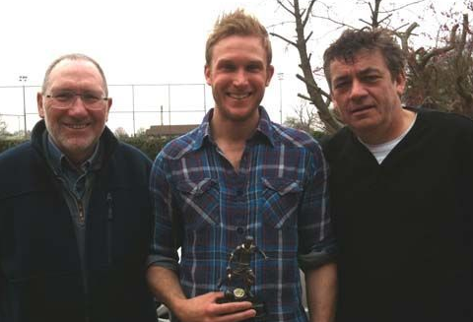
Tom Brooks receives a trophy from Bob and Trevor to mark his 200th appearance for the club.

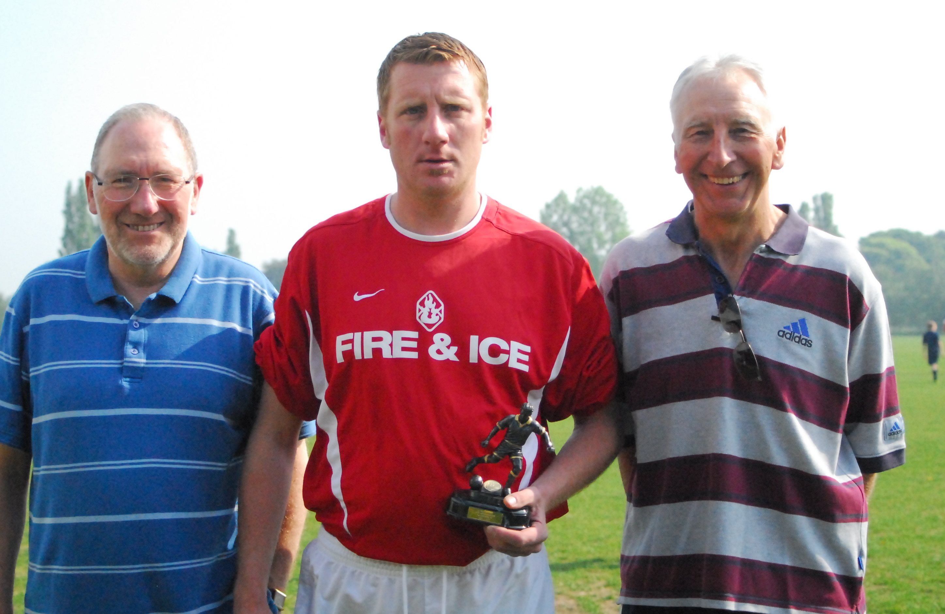

Bob and Pat present James Bullamore with a memento to celebrate 400 Taverners’ games.

Tavs ‘milestones’

Taverners Presentation Night highlights
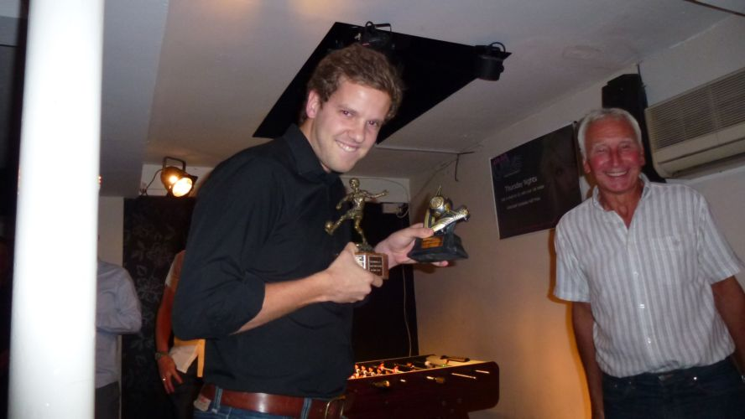
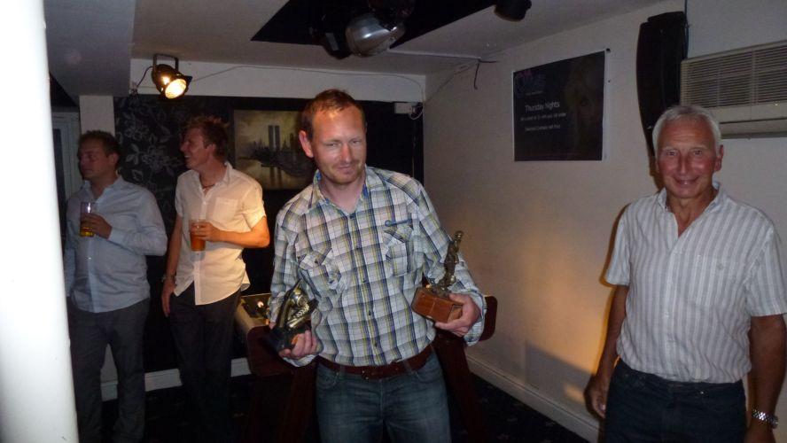
Players of the Year Andy Lambert (left) who won both the 1st team ‘Manager’s Player’ and the ‘Players’ Player’ together with the Goal of the Season and Philip ‘Dippy Bowman who won the former award for the reserves.

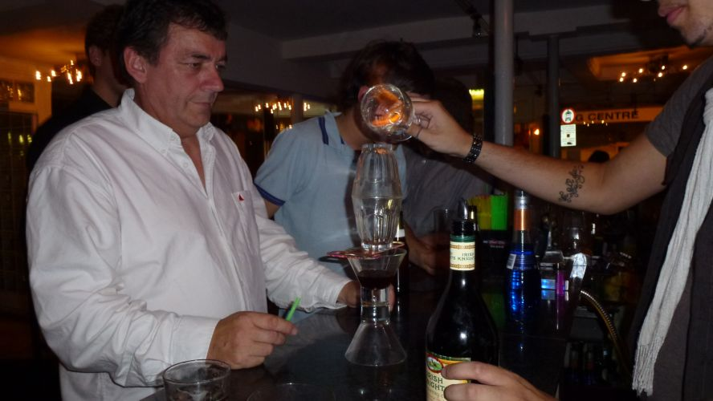
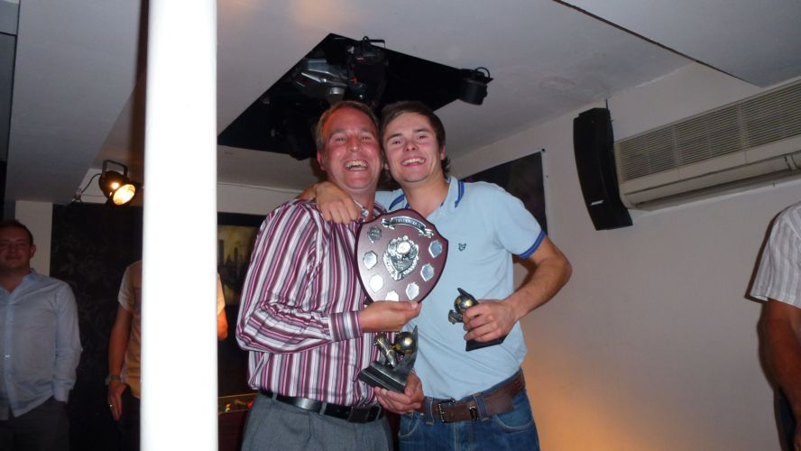
Matt Davis (left) and Matty Wray celebrate several trophies: Matt was the reserve team’s Manager’s player & Clubman and shared the Most Improved Player with Matty, who also won the Top Newcomer award.

Trevor Hollinsworth (right) picked up the ‘Golden Boot’ as reserve team leading goalscorer.

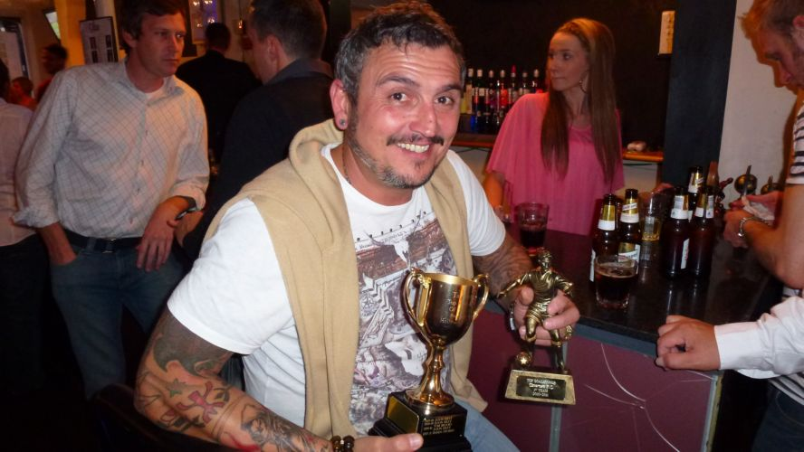

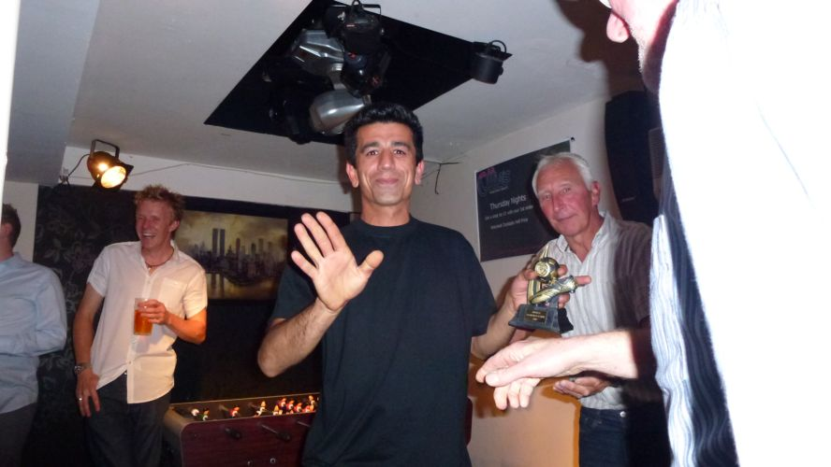
Tim Atabaky (left) scored the reserve team’s Goal of the Season while Daren Stevens received the 1st team leading scorer’s ‘Golden Boot’ award.

ISFL Premier & RM 1 – Final divisional tables
ISFL Premier Division
 | P | W | D | L | Pts
Ipswich Thistle | 18 | 13 | 3 | 2 | 42
Shotley Rose | 18 | 13 | 2 | 3 | 41
Belstead Arms | 18 | 19 | 2 | 6 | *26
Holbrook Swan | 18 | 7 | 5 | 6 | 26
Underwoods | 18 | 6 | 7 | 5 | 25
Ferryboat | 18 | 6 | 3 | 9 | 21
Ransomes Sports | 18 | 6 | 3 | 9 | 21
Unicorn | 18 | 5 | 3 | 10 | 18
Capel Plough | 18 | 5 | 4 | 9 | *16
Taverners | 18 | 1 | 4 | 13 | 7

ISFL RM Division 2
 | P | W | D | L | Pts
Taydal | 20 | 13 | 3 | 4 | 42
Walton Rovers | 20 | 14 | 0 | 6 | *39
Bramford Cock | 20 | 13 | 3 | 4 | *39
Felixstowe Athletic 03 | 20 | 11 | 4 | 5 | 37
Rushmere Selkirk | 20 | 9 | 2 | 9 | 29
Holbrook Swan reserves | 20 | 8 | 3 | 9 | 27
Orwell | 20 | 7 | 8 | 7 | 27
Ipswich Hospitals | 20 | 6 | 3 | 11 | *18
Kesgrave Athletic | 20 | 4 | 5 | 11 | 17
Felixstowe Harpers res. | 20 | 4 | 2 | 14 | 14
Taverners reserves | 20 | 5 | 1 | 14 | *13
* Adjustment made
The last word......

It was heartening for everyone connected with the Tavs to see such good attendances at the club's AGM and the presentation night held at our sponsors' Ollie's Cocktail Cafe.
At the former, the existing club committee was strengthened by the addition of Paul Strutt who will be looking after social activities and hopefully re-activating the club's Easter trips to Brussels.
The presentation night saw the following awards handed out by club chairman Pat Elvin:
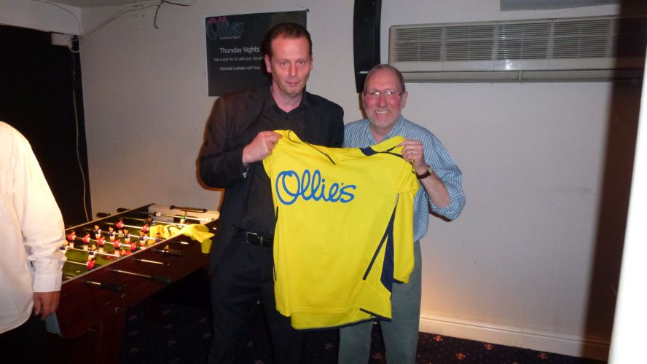
1st team:
Players' Player, Manager's Player & Goal of the Season: Andy Lambert.
Golden Boot (top goalscorer): Daren Stevens.
.
2nd team:
Players' Player: Philip Bowman.
Manager's Player: Matt Davis.
Goal of the Season: Tem Atabaky.
Golden Boot: Trevor Hollinsworth.
.
Most Improved Player: Matt Davis & Matty Wray.
.
Clubman: Matt Davis.
.
Best Newcomer: Matty Wray
.
Presidents' Cup: Bill Fleming
.
A few pictures of the evening appear in this publication and others
A highlight of the Presentation Night was the presentation of two new playing strips by our sponsors Ollies.
can be viewed on the Tavs' website: www.tavernersfc.org.uk
The ISFL annual meeting saw Taverners reserves win the 'Fairplay
trophy for their division; a fine achievement.
In the last News & Review, we mentioned the planned revival of the well-remembered ‘Crane Sevens’ competition in which the Tavs took part for many years but, unfortunately, this had to be shelved for this year due to lack of support.

Everyone has been keeping an eye on the progress of two Taverners stalwarts – Pilky and Frank – over the last few weeks and months and we are pleased to report that they are both making great strides towards regaining full health; our best wishes continue to go to them.

Close-seasons seem to get shorter and shorter and we shall very soon be starting friendlies in preparation for the 2011/12 campaign. Watch out on the club website for details.

The last word......

 |  | 1st team - Premier Div. |  | 2nd team - Div. 2 (RM)
Sept | 5th | Capel Plough | a 2-2 | Felixstowe Athletic 03 | a 1-2
 | 12th | Ransomes Sports (Sun. Cup 1) | h 2-4 | Capel Plough reserves (S/S) | a 3-4
 | 19th | Ferryboat | h 2-2 | Holbrook Swan reserves | a 2-1
 | 26th | Margaret Catchpole (S/Cup 1) | a 0-2 | Kesgrave Social Club (J/C) | h 4-3
Oct | 3rd | Holbrook Swan | h 2-3 | Ipswich Hospitals | a 2-6
 | 10th | (Sun Cup / Sun Shield 2)
 | 17th |  |  | Felixstowe Harpers res. | a 8-2
 | 24th | Ascio | h exp. | Worlingworth (Jun. Cup) | a 6-7
 | 31st | Unicorn | h 0-0 | Orwell | a 3-3
Nov | 7th |  |  | Rushmere Selkirk | h 4-2
 | 14th | AFC Woodbridge | a exp | Walton Rovers | h 2-4
 | 21st | Ascio | a pp | Taydal | a pp
 | 28th | Ransomes Sports | a pp | Kesgrave Athletic | h pp
Dec | 5th | Belstead Arms | h pp | Walton Rovers | a pp
 | 12th | Belstead Arms | a win | Bramford Cock | h 2-3
 | 19th | Capel Plough | h pp
 | 26th | Boxing Day
Jan | 2nd
 | 9th | Ferryboat | a 1-3 | Taydal | h pp
 | 16th |  |  | Felixstowe Athletic | h 1-3
 | 23rd | Ipswich Thistle | a 1-3 | Walton Rovers | a 1-2
 | 30th | Ransome Sports | a 1-3
Feb | 6th | Shotley Rose | h 1-2 | Kesgrave Athletic | a 0-8
 | 13th | Unicorn | a 0-3 | Orwell | h lost
 | 20th | Shotley Rose | a 3-5 | Kesgrave Athletic | h 3-2
 | 27th
Mar | 6th
 | 13th | Ransomes | h 0-2
 | 20th |  |  | Felixstowe Harpers res. | h 3-2
 | 27th | Underwoods | a 1-1 | Holbrook Swan reserves | h 0-1
Apr | 3rd | Underwoods | h 0-1 | Rushmere Selkirk | a 0-3
 | 10th | Capel Plough | h 1-2
 | 17th | Belstead Arms | h 0-12 | Taydal | a 1-4
 | 24th | Easter |  | Easter - Taydal | h 0-3
 | 27th |  |  | (Wed) Bramford Cock | a 0-5
May | 1st | Holbrook Swan | a 0-3
 | 4th |  |  | (Wed) Ipswich Hospitals | h 0-1
 | 8th
 | 11th | (Wed) Ipswich Thistle | h 0-5

Taverners FC fixtures 2010-2011

