TAVERNERS
News & Review

Issue 256 – November 2010 - e-version 5

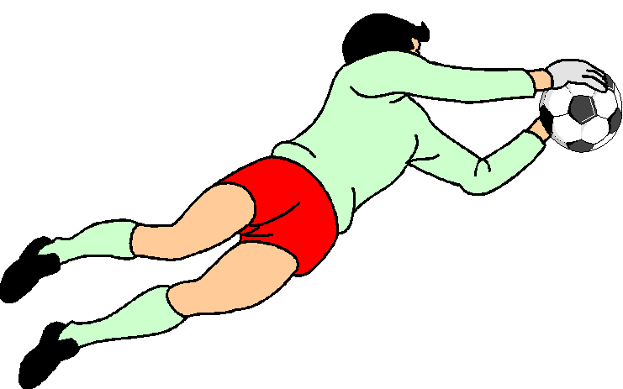

Club sponsors:
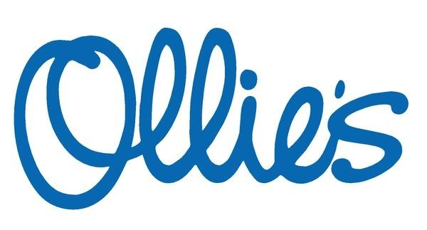

Website: www.tavernersfc.org.uk

TAVERNERS FOOTBALL CLUB

Established 1967

Members of the Ipswich Sunday Morning Football League since 1972
(Members of the Gippeswyk Sunday League 1967 - 1972)

Members of the Saul Charity Cup

Affiliated to the Suffolk County Football Association : No. GS100083

Colours:
1st team: White shirts, white shorts, black socks
2nd team: Yellow shirts, navy blue shorts, red socks

Home ground: Greshams Sports Club, Tuddenham Rd, Ipswich

Club Committee:

Chairman: | Pat Elvin | Tel: 748206
Vice Chairman | Bill Fleming | Tel: 742713
Secretary/1st team manager: | Bob Bullamore | Tel: 729586
Treasurer: | Gary Pilkington | Tel: 01394 386686
2nd team manager | Trevor Hollinsworth | Tel: 07802176434
Officers | James Bullamore | Tel: 07917185487
 | Bevan Burgess | Tel: 612693
 | Daren Stevens | Tel: 07979851887
 | Tom Brooks | Tel: 740868
 | Duncan Southgate | Tel: 07834614677

Club honours:

1st team: | Winners | Ipswich SML Division 2 | 1993/94
 | Winners | Fairplay - Division 2 | 2001/02
 | Winners | Fairplay - Premier Div. | 2003/04
 | Runners-up | Ipswich SML Division 1 | 2004/05
 | Winners | Fairplay - Premier Div. | 2005/06
2nd team | Winners | Ipswich SML Reserve Cup | 1994/95
 | Winners | Fairplay - Division 5 | 2001/02
 | Winners | Fairplay - Div. RM 1 | 2009/10
 | Runners-up | Ipswich SML Division 7 | 1985/86
 | Runners-up | Ipswich SML Division 5 | 1987/88
 | Runners-up | Ipswich SML Reserve Cup | 1992/93
 | Runners-up | Ipswich SML Reserve Cup | 2002/03
 | Runners-up | Ipswich SML Reserve Cup | 2003/04
Club | Runners-up | Suffolk FA Fairplay Award | 2000/01

Taverners
News & Review

Issue no. 256 – 25 November 2010

Looking back with the Tavs
….from 5 to 40 years

5 years ago (October 2005)………The first team had a poor month. A win in our previous match against Belstead Arms proved no inspiration as we were beaten 3-1 by Copleston; James Rice scored the Taverners goal.

We were then beaten 4-0 at home by Felixstowe Harpers in the Sunday Cup and the 5-2 away to Bourne Vale. Here, we scored first and again to equalise at 2-2 but fell away badly. James Bullamore (penalty) and Trevor Hollinsworth scored our goals.

Despite having the bare eleven, the reserves produced a great performance to knock old rivals Bourne Vale reserves out of the Sunday Shield with a 5-0 win. The goals were scored by Mike Cura, Tony Monaghan, Sam Vincent and Sam Burrows 2.

Matt Davis commented – in Eric Cantana style – that “the team proved that the diver who remains afraid of the shark never captures the pearl!”

The following week saw the reserves repeat the process, beating Bourne Vale reserves 4-1 but our opponent’s later withdrawal meant that the result was expunged. For the record, our scorers were Sam Vincent, Sam Burrows, Karl Dawson and paul Strutt.

A 3-2 defeat at the hands of Murray Rangers followed, despite Bevan Burgess opening our account after about 45 seconds. Mike Cura scored the Tavs’ second.

The Tavs then lost at home to Pauls by 4-2, our goals scored by Sam Burrows – the first a penalty and the second a tuck-in at the far post after good work by Sam Vincent.

We then made more progress in the Sunday Shield with a 3-2 win over Premier Pool reserves at Greshams.

A vital point was Matt Davis’ early penalty save and we quickly took the lead through Sam Burrows’ long-range chip over the keeper.

The Pool equalised before good reactions from Vaughn Gledhill enabled him to pounce and score for a 2-1 lead. Another leveller was followed by a winning goal from Mike Cura, heading in Sam Burrows’ deft free-kick.

10 years ago (October 2000)………The first team’s difficult season continued with a 3-2 defeat away to Bourne Vale, our goals both being penalties from Andy Spivey. We managed to score first (through Trevor Hollinsworth) at home to Melton YCOB and certainly produced a better performance but Melton fought back to win 2-1.

A 5-0 defeat by St Clements saw the Tavs exit the Sunday Cup but we then found some form to win 9-3 away at Sizewell Sports. Our delight turned to dismay a few weeks later, when Sizewell withdrew, but, for the record, our scorers were Trevor Hollinsworth 3, Richard Fuller 3, Tim Howard, Paul Oakshott and Daren Stevens.

The reserves began with a 4-0 win over Margaret Catchpole in the Sunday Shield, our scorers being Tim Howard (penalty), Gary Pilkington, Tom Parker and Paul Oakshott.

This represented our first win of the season but we were quickly brought down to earth by a 6-2 home league defeat at the hands of Chantry Grasshoppers. Tim Howard and Stuart Godden scored the Taverners goals.

However, a tremendous double-fight back against Trinity saw the Tavs win 3-2 with goals from Danny Marsh and Paul Oakshott 2; ‘Oaky’s’ winner was a spectacular 30 yard free-kick.

Perhaps the most dramatic Cup finale in the Club’s history followed. At the end of extra time, the Tavs and Stow Pickerel reserves were level at 2-2 (our scorers being Tom Walker and Danny Marsh).

A penalty shoot-out followed and, incredibly, after 20 spot-kicks, the teams remained level with everyone having found the net. Stow missed their next penalty and it was left to Pat Elvin - back in the side after a lengthy absence through injury - to fire home the winning goal and send the Tavs through to the next round!

A week later, Taverners and Felixstowe Grosvenor went to extra time in their Sunday Shield tie with the score at 2-2 after 90 minutes. Unfortunately, it was Grosvenor who grabbed the winner. Our goals had been scored by Paul Oakshott and Danny Marsh.

15 years ago (October 1995)……..The first team returned to League duty with a Division 1 (now Premier) win over Dickerson by 3-1 (away). Our goals came from Gary Cunningham 2 and Paul Oakshott.

We then visited Capel Plough with a goalkeeping problem described in the News & Review of the day….“an injury to Mark Moore on the Saturday resulted in a goalkeeping crisis and, with Tony Thomas still uneasy about his own back injury, Pat Elvin bravely donned the gloves.“…..how many times has that happened over the years!

We lost 5-3 to Capel (Gary Cunningham, Kevin Oxborrow and an own goal scoring) and we were then beaten 4-3 by Blandford after holding a 3-1 lead. New signing Stephen Lee kept goal while Gary Cunningham scored a hat-trick for the Tavs. However, it was already very clear that we faced an almighty task to retain our Division 1 status.

The reserves made their exit from the County Sunday Shield, beaten 2-0 by Old Times and were then defeated 6-0 by Onehouse. The Tavs were forced to reorganise early on when a most unfortunate collision between Tim Howard and Andy Philpot saw Andy needing hospital treatment while Tim battled on despite being badly shaken.

We bounced back well to beat SEH 2-0 with goals from Mike Ray and Neil Bennett but then saw a 2-0 lead at home to Kirton United disappear as Kirton drew level and then scored a late winner. Mike Ray scored both our goals.

20 years ago (October 1990)…………. The first team made an early exit from the County Sunday Cup when they lost 1-0 to Premier Pool from Division 5. A week later we visited Ambassadors in a league game but were unable to return to winning ways. Daren Stevens gave Taverners the lead but Ambassadors fought back to equalise and grab a point.

Spirits were lifted by a fighting display away to Haughley United in the Senior KO Cup. Haughley took the lead but the Tavs came back with goals from Andy Glover and Daren Stevens and then defended resolutely to win 2-1. A 4-0 win over Hadleigh Goldstar followed, Simon Finch 2, Terry Pilbro and Kevin Oxborrow scoring the Tavs goals.

The reserves played Sutton United only a fortnight after beating them at home 5-1 and were brought down to the earth by a 2-1 defeat. John Simpson scored the Taverners goal. A far better performance followed at home to Eastern Electricity in the Sunday Shield. We took the lead through Jamie Needham but a scrambled equaliser only minutes from time sent the tie into extra time. Unfortunately, Eastern Electricity scored twice more for a 3-1 extra-time win.

A great game against high-scoring Harleys saw the Tavs secure a last-gasp 3-2 win thanks to a late goal from Bevan Burgess who outpaced the defenders in a run from the half-way line before scoring. Our earlier two goals came from Jamie Needham.
The month ended with a fine 2-1 win over Capel Plough reserves from Division 6 in the Reserve Cup. Neil Bennett and John Simpson scored the Tavs goals.

25 years ago (October 1985)…. The first team scored a famous League Senior Cup victory, beating the previously unbeaten Stow Vandals 2-1 in a tough but sporting encounter. Tery Pilbro and Elwyn Goulding scored the Taverners goals.

Disappointment followed with a 3-1 defeat at the hands of Claydon, Steve Nunn scoring the Tavs consolation with a spot-kick.

We got back to winning ways with a 2-0 win over Holbrook Rovers, Elwyn Goulding scoring both goals. A goal ten minutes from time saw Stowmarket Athletic win our Sunday Cup 1st round tie but we bounced back the following week to beat Telephone Engineers 4-1 in the League Cup. Steve Nunn (penalty), Elwyn Goulding, Terry Pilbro and Chris Lushington scored for Taverners after we had gone behind early on.

The reserves began the month with a 2-2 draw away to Sutton United, our goals coming from Elwyn Goulding and Andy Glover but we were then blasted out of the Sunday Shield 11-2 by the outstanding Blandford. Our scorers were Daren Stevens and Stuart Webb.

Spirits were revived by a 4-0 win over Orford Town at home, the goals coming from Daren Stevens, Dickie Davis, Gary Cunningham and Chris Voller.

We then beat Queens (away) 2-1. The game was notable for seeing the debut (as substitute) of new signing Ian Green, while Pat Elvin marked his return from injury by scoring both goals.

30 years ago (October 1980)……. The month opened with a fine performance from the first team in a League Cup Senior Cup tie against Melton YCOB from Division 2. The Tavs won 6-0 with goals from Martyn O’Leary, Steve Baker 2 and 3 own goals!

Another cup tie saw us entertain Division 1 (now Premier) side Heathfield and and the Tavs were beaten 2-1 despite a tremendous fight-back in the second half which saw Pat Elvin score a goal which is till remembered as one of the finest scored for the Tavs over the years.

We then produced a fighting display at Needham Market to beat old rivals Rampant Horse 2-0. Both goals came from Pat Elvin, the first a hard-driven corner which flew into the net and the second a good finish after a fine build-up. With a free league date, we visited RAF Wattisham a week later and were beaten rather tamely by 3-0.

The reserves had a break from league duty to beat GRE reserves 5-2 in a friendly. Our scorers were Bill Ormsby 2, Ian Scott, Chris Lushington and an own goal. We were then beaten 4-1 by Alderton after establishing an early lead through Mick Flude. A friendly, against Aldridge Sports reserves ended in a 4-2 defeat but we bounced back with a win - again a friendly - over P & O Roadways by 4-0. Our goals came from Mick Flude 2 and Chris Lushington 2.

35 years ago (October 1975)……. The month began with a 5-2 win over Tower Rampants YC in the Sunday Shield with goals from Glen Parker (penalty), Mick Flude, Paul Miller 2 and an own goal but we then suffered a 4-2 defeat at the hands of Hadleigh Town.

Paul Miller and Mick Flude scored the Tavs goals but the player who really made a mark on the game was Hadleigh’s Cecil Pittock - a player we were delighted to see wearing a Taverners shirt 12 months later!

We lost 2-1 to Thurleston YC reserves (Paul Miller scoring) but quickly bounced back with a 6-3 Sunday Shield victory over the Duke of Sussex at Bourne Park. The goals came from John Davey 2, Paul Miller, Glen Parker, Kelvin Whitmore and Mick Flude.

40 years ago (October 1970)…..Taverners began the month unsteadily, losing a Burton Cup tie 2-0 to the Haven at the Airport rec. (now Gainsborough Sports Centre).

However, we came back to give a tremendous ‘backs to the wall’ display against a Holbrook YC side who had won all their previous Gippeswyk League Division 3 games by very high scores. Those who were present will tell you that the afternoon was one of the most memorable in the Club’s history as Taverners gained a 2-2 draw in front of a 200-strong partisan crowd. Martin Buck and Keith Hubbard scored for the Tavs.

Tavs’ Co-President John Steward (our centre half and also, ironically, a native of Holbrook) recalls the closing stages of the game as we held on desperately with ten men: “…….midway through the second half, Holbrook drew level and, roared on by the crowd, gained corner after corner in their efforts to score the winner. From one of these corners, a goal-bound header was craftily saved by the hand of our left back, Ralph Murray, but, as referee Mr Ladbrook and linesman Frank Fleming were unsighted, we escaped……although I must confess to being worried when I saw the crowd throwing a noose over a nearby tree!“

We produced a solid performance to beat Hadleigh Falcons 3-0 at our Woolverstone home ground with goals from Ross Turtill, Adrian Dickerson and Russell Langham. A week later, we travelled to Kesgrave YC and a hard-fought game finished 0-0 - few chances were created but it was another disciplined defensive display by the Tavs.

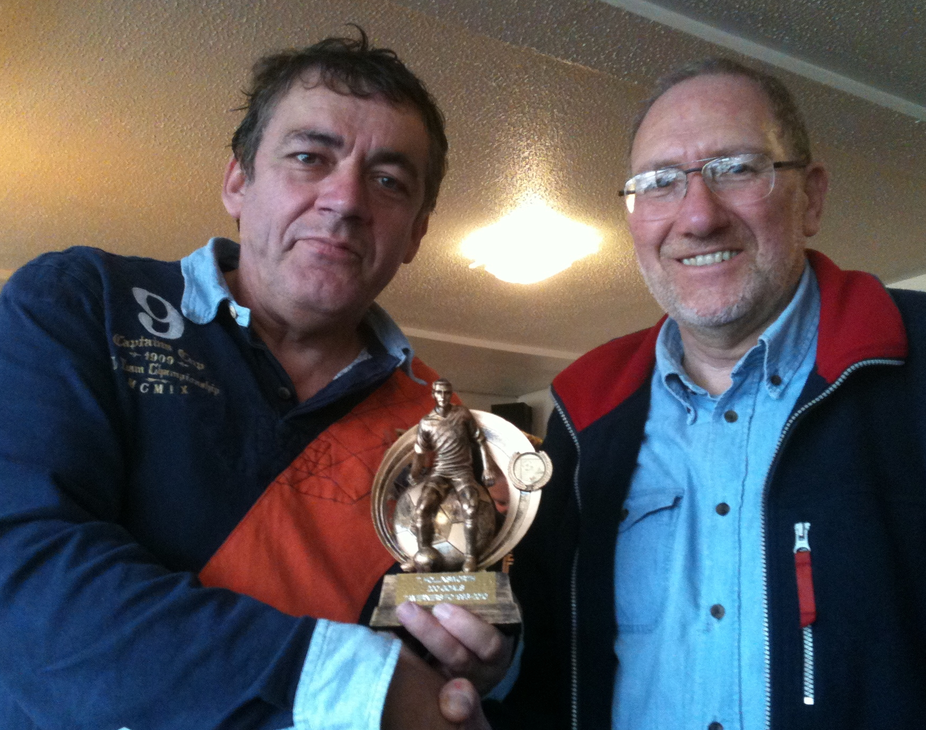

Trev notches his 200th goal for the Tavs!

The reserves’ match against Ipswich Hospitals – despite not producing the hoped-for result – saw Trevor Hollinsworth register his double century of goals for the club.

The player-manager’s goal came direct from a corner and he remains hard on the heels of all-time leading scorer Gary Cunningham who has 222 goals to his credit.

Trev is seen receiving a memento to mark his fine achievement from Bob Bullamore.

First team focus - Bob Bullamore reports

Tavs’ spirited come-back grabs a point... Capel Plough 2, Taverners 2

After a mixed-bag of pre-season friendly results, we began the club's 44th Sunday league campaign with a visit to Capel Plough.
The need to make team-changes meant that we took a long time to settle and, by that time, Capel were 2-0 ahead and might have extended their lead without the clean handling and anticipation of Clive Halls in the Taverners goal.
We began to come into the match and had a boost to our confidence with a superbly worked goal just before the break. A fine passing move ended with Lee Riley crossing well and Andy Lambert rising at the far post to head home.
We were forced to defend early in the second period but then gained a series of corners and, from the third of these - clipped to the near post by Duncan Southgate - Henry Chard headed forcefully home for the equaliser. (Apologies, Duncan for omiting your 'assist' in the Geen'un notes!)
Having fought back so well, we were determined to hold the point and everyone worked hard all over the pitch to keep Capel at distance. Our defending was intelligent and resolute - witness one great tackle by Henry late on - while Clive continued to dominate his box.
A point well won.
Team: Halls, Chard, Bullamore, Leeks, Nunn (Sub: Wilcox), Lambert, Southgate, L Riley, Cunningham, Gledhill, Strutt

Ransomes’ turn to fight back....Taverners 2, Ransomes Sports 4

The confident and lively start made by the Tavs - boosted when we twice took the lead - ended in disappointment as Ransomes Sports twice came back from behind and then scored two quick goals in the second half to progress to the next round.

We began strongly and took the lead when Duncan Southgate's inswinging corner was headed home by Vaughn Gledhill. A one-on-one chance for Vaughn was saved shortly afterwards and we were punished when Ransomes netted an equaliser.
New signing Ben Norfolk was showing up well and he fired in our second to restore the lead. Unfortunately, a lack of awareness and concentration cost us dear as Ransomes levelled the scores to 2-2 at half-time. We were forced back at the start of the second half and Clive Halls again showed fine form in goal while, on another occasion, Andy Lambert made a double block near his own goal-line to save what looked like a certain goal.
Poor defending led to Ransomes taking the lead at 3-2 and they added a fourth shortly afterwards. Although Henry Chard headed over for the Tavs and Clive had to be alert at the other end, there were few chances.
The match was played in excellent spirit and well refereed by Graham Wilks. It was good to see Andy Reilly - an ex-Tav from a few years back - and his wife Lyn, both part of the Ransomes set-up while their son was a thorn in our side all morning!
Team: Halls, Chard, Bullamore, Lambert, Nunn (Sub: Pearson), Parry (Sub: Farris), Southgate, Brooks, Cunningham, Gledhill, Norfolk.

A hard-earned point....................................................................Taverners 2, Ferryboat 2

The first team entertained Ferryboat - with whom we had fought out two draws last season - and started well, absorbing pressure, but catching our opponents out with quick counter-attacks.
Ben Norfolk made a good break on the right and, when his cross caused confusion in the Ferryboat defence, Eamon Mongan pounced to fire into the corner. A second Taverners goal followed a neat build-up - Duncan Southgate being prominent - and this time Norfolk sped through to beat the advancing goalkeeper.
The Tavs were having to defend - with James Bullamore and Andrew 'Panda' Jacobs solid in the middle of the back four - but a rather controversial goal brought Ferryboat back into the match immediately after the break.
A second Ferryboat goal levelled the scores but Taverners continued to fight for everything and - with Vaughn Gledhill working hard throughout up front to take pressure off his defenders - we held out for a 2-2 draw.
Team: Halls, Chard, Bullamore, Jacobs, Cunningham, Aldred, Mongan, Lambert, Southgate, Gledhill, Norfolk (Sub: R Horsfall)

Another cup exit on a poor morning for the club............Margaret Catchpole 2, Taverners 0

However disappointing the eventual outcome of this Cup tie proved, we began in determined mood and played some good football for the first half hour. Several crosses from Gary Pilkington spelt danger and it only seemed a matter of time before we scored. Unfortunately, we lost possession, failed to recover and a speedy attack ended with an angled shot hitting our net.
Undeterred, we attacked again although one sensed it would not be our day when Marcus Webb was clearly fouled as he was poised to head home after a goalmouth scramble and no penalty was forthcoming.
Our good intentions for the second half were dealt a severe blow when a short back-pass resulted in the Catchpole doubling their lead immediately after the break.
A head injury to Gary Cunningham saw him replaced by Tem Atabaky and he went the closest to scoring with a snap shot which hit the underside of the bar.
Tempers all-round worsened as the game approached its end and, after a flurry of yellow cards, we unfortunately saw two players dismissed (for second cautions) to round off a bad morning.
Team: Halls, Southgate, Bullamore, Webb, Cunningham (Sub: Atabaky), Lambert, R Horsfall, Mongan, Pilkington, Gledhill, Norfolk

Good first half but match slips away.....Taverners 2, Holbrook Swan 3

The first team – showing a number of changes – began their home match against the Martyn O’Leary-led Holbrook Swan in determined and positive mood and our first half performance was described by club chairman pat Elvin as “the best for some time.” The hard-working Liam Claydon saw an acrobatic effort touched onto the Swan bar and the rebound was scrambled clear but this was only a reprieve as a short corner move led to Duncan Southgate crossing and Ben Norfolk firing home.
We doubled our lead when a neat pass from Liam Claydon found Daren Stevens in space and he drove the ball past the keeper.
The Swan reduced the arrears just before the break as our marking was found wanting. Holbrook enjoyed a lot of possession in the second period despite good work by Luke Farris on his first team full debut but it took a freakish goal to register their equaliser. With the Tavs clearly tiring, the Swan took the points with a late goal despite two superb blocks by Marty Smith, who was standing in for the injured Clive Halls in goal.
This was a hard-fought encounter, well handled by referee Louis Dawson.
Team: M Smith, Southgate, Bullamore, Lambert, Pilkington, Gledhill, Strutt, Claydon, Farris, Stevens, Norfolk (Sub: Brittain)

Another difficult morning for the Tavs.................................................Taverners 0, Ascio 6

From the first whistle it looked as if we were going to struggle to keep our heads above water against an Ascio side who were so quick in attack and had too many players who were capable of controlling the game and directing events.
Offside thwarted Ascio on several occasions but, once they got their noses in front, and certainly when they scored a second goal just before half-time there only looked to be one winner.
By the end, we were grateful to some last-ditch defending and fine goalkeeping by the debutant James Dines for keeping the score down to six.
Dinesy's good work in goal was a plus and other bright-spots were Luke Farris' tireless contribution in midfield and Daren Stevens battling away up front.
Team: Dines, Southgate (Sub: Wilcox), Bullamore, Lambert, Burgess, Strutt, Farris, Gledhill, Pilkington, Stevens, Norfolk.

Tremendous effort from everyone.....................................................Taverners 0, Unicorn 0

A much-changed Taverners side went into a tricky match against Unicorn with great spirit and determination and fully deserved the point and the clean-sheet.
The first half saw the Tavs shade things in a tremendous battle fought out for the main part in midfield. After the break, Unicorn had more of the play but we defended well while, further forward, no one flinched a tackle and we deserved a little luck when two Unicorn efforts came back off the woodwork.
Vaughn Gledhill deserves our thanks for a last-minute switch to goalkeeper while Ben Norfolk did well in midfield and Matty Wray made a superb first-team debut at left back.
All in all, a solid and spirited team performance.
Team: Gledhill, Bowman, Bullamore, Lambert, Wray, Norfolk, Claydon, Farris, Brittain, Parry, Stevens.

First points for the Tavs!....................................................AFC Woodbridge 4, Taverners 5
With AFC Woodbridge fielding a depleted side at the kick-off, the Tavs got right on top and took the lead when Duncan Southgate's corner was flicked on by Vaughn Gledhill and Henry Chard – on a weekend back from university - scored from close range.
Further chances were created and missed while the Woodbridge goalkeeper made several good saves. As Woodbridge's playing numbers increased, Taverners found it difficult to adjust their game and - as a result of a lack of concentration - we conceded the equaliser. Loud appeals for offside - supported by Dave Vincent's flag - went strangely unheeded as Woodbridge then scored a second and grabbed a 2-1 lead.
We shrugged this setback off by drawing level when Duncan Southgate's dangerous free-kick was headed home by Ben Norfolk. A handling offence then gave James Bullamore the chance to net a penalty to put the Tavs ahead again and then Vaughn Gledhill scored for a 4-2 interval lead.
The next goal was clearly going to be very important and it went our way when a free-kick was netted by Duncan - who did well in place of the unwell Andy Lambert - but Woodbridge refused to give up and two quick goals ensured an anxious finish before we travelled home with a 5-4 win and - for the first time this season - three points.
Team: Dines, Chard, Bullamore (Sub: Cunningham), Southgate, Pilkington, Farris, Gledhill, Brittain, Wray, Parry, Norfolk.

Reserve Scene - Trevor Hollinsworth reports

Tavs unlucky to start with a blank morning..Felixstowe Athletic 03 2, Taverners reserves 1
The pre-season has been a little mixed as far as results and available players has been concerned so even though we have had a few friendlies this still had the feel of our first match.

Felixstowe started the better team with Taverners defending hard to stay in touch with the game. Just as things were leveling out between the sides Felixstowe scored from what seemed to be a thwarted attack. The forward found himself faced by 2 defenders and had nowhere to go so decided to hit and hope from just inside the 18 yrd box. It was with some disbelief that Taverners watched the ball curl into the far corner with no power and no pre thought.

This however did spur Taverners on and they started to make in roads. Sam Burrows and Tem Atabaky doing well for the away side. It was from a Sam Burrows long throw that Taverners equalised with Daren Stevens challenging for the ball which dropped to the corner of the six yard and, with his back to goal, Trevor Hollinsworth was there to volley home.

A fair half time score line. Taverners had a full 50% of the play in the second half. Tem Atabaky went close. As the game wore on the fitness began to show and loss of concentration caused Taverners some problems. Felixstowe scored again with 15 minutes to go when their forward was left completely unattended on our left. He had a clear run on goal to score.

Taverners fought on and fully deserved a draw. With just minutes to go two golden chances went astray leaving them with a frustrating defeat on the opening day of the season.
Team: A Smith, Aldred, Stevens, Webb, Burgess, Burrows, Fisk, Mongan, Pilkington, Hollinsworth, Atabaky, (Subs: Hunt, Davis, Holmes)

So many chances, so many misses!................Capel Plough reserves 4, Taverners reserves 3
You are 12 yrs old, It's a beautiful sunny Sunday. You are dressed in your brand new kit which is a little too big. Everyones family are on the sideline watching and you step out onto the local rec with your school mates. You are playing the local cub scouts and you win 12 - 0 and score 6 goals.
That was the last time you were involved in such a one sided match. The conversation in the dressing room after the game was unanimous. How the hell did we not win.

From the opening few minutes it was obvious we were not playing a good team. It was also clear that the referee for the day was nervous as he was being assessed. The only thing that could beat us today was ourselves. So with just 20 minutes gone we were 2-0 down. Both caused by mistakes by ourselves. At this point we woke up from our dream state and started to play. Chance after chance came our way. Again the only people at fault were ourselves. Bad decisions on the final ball, or a player who thought he could beat just one more defender and score himself. If we had used our teammates Capel would have been played off the park by half time. Instead we lost yet another goal and had to settle for a 3-1 scoreline.
Gary Pilkington scored for Taverners after Trevor Hollinsworth hit a free kick under the wall from a free kick. Gary scored from close range.

Forced changes at half time through injury to Matt Davies saw Dippy Bowman make his first appearance of the season. We re-grouped and started well in the second half. Taverners pounded the Capel goal with attack after attack. From a corner Trevor Hollinsworth made it 3-2 with a goal direct from the corner. The onslaught continued. The referee had made some very strange decisions which although annoying had not affected the game too much. But when standing just yards from a player he fails to see him push the ball passed our last defender with his arm to leave him clean through then you have to say he had eventually killed off the game as they scored from the resulting attack. It was Capel's only shot in the second half and even so it's fair to say it should have been saved.
Again Taverners surged forward and with just 5 minutes to go scored when Bevan Burgess got above everyone to head home from a corner. Taverners had, with no exaggeration, seven clear attempts on goal in the last 2 minutes including Bevan Burgess seeing another header cleared off the line.
But with some disbelief the final whistle was blown and the score 4-3 to Capel Plough.
Team: A Smith, Aldred, Webb, Davis, Burgess, Fisk, Mongan, Pilkington, Atabaky, Hollinsworth, Strutt (Subs: Bowman, Brittain)

The Tavs grab the points..........................Holbrook swan reserves 1, Taverners reserves 2
Due to other commitments and injury Taverners travelled to Holbrook with just 11 players. But this just seemed to bring on the Dunkirk spirit into the team.
The game started with Holbrook having the lion share of the play and Taverners found themselves defending. But with good leadership for Captain Pilkington they began to find their feet after 15 minutes. Although Holbrook did continue to attack their efforts on goal were from distance and not very effective. Taverners battled on and against the run of play scored when a long clearance from Alex Smith in goal was chased down by Tem Atabaki. He stole the ball from one of their defenders and set off from the half way line goalward. He beat three defenders leaving him a one on one with the advancing keeper who he easily beat with a low shot to the bottom left.
Taverners held their lead until 15 minutes into the second half when goalkeeper Alex Smith called for the ball only to see it bounce through his legs leaving the forward an open goal. It has to be said that this was a rare mistake on the day as Alex played well.
Taverners began to press forward and had opertunities to regain the lead as did Holbrook. Again as in past weeks the decision making in front of goal was poor and Taverners failed to put a single shot on target in this half. The only opening for success was from set pieces. Corners caused major problems for Holbrook. It was with just 10 minutes to go a free kick which produced the winning goal. The ball swerved in from 35 yards was met well by Philip Dippy Bowman to head home.
With just minutes to go an equalizer was avoided when Holbrook went clean through but with some determination Jamie Brittain caught and tackled the forward on the 18 yrd box to insure the victory.
On reflection it was a stolen win but good to see the luck going Taverners way for once. Big performances from Bevan Burgess, Andy Spivey, Geoff Leeks, Dippy Bowman, Jamie Bittain and Gary Pilkington.
Team: A Smith, Fisk, Leeks, Spivey, Burgess, Burrows, Bowman, Brittain, Pilkington, Atabaky, Hollinsworth.
Taverners progress in Junior Cup..........Taverners reserves 4, Kesgrave Social Club 3 (aet)
It was perfect football weather for this Junior cup match. Taverners started cautiously and Kesgrave took some advantage but with no end product. It was Taverners who had the first chance when Daren Stevens was brought down in the box for a penalty. Unfortunately a miss hit from Trevor Hollinsworth saw the keeper save with his legs.
This however spurred Taverners on and before half time they should have put the game beyond reply. Trevor Holllinsworth had a number of chances but saw each one go wide of the goal.
After 10 minutes of the restart Kesgrave took the lead. Taverners replied immediately through Daren Stevens who was on hand to head home a Sam Burrows cross. 10 minutes later Taverners took the lead from a corner, Daren Stevens was again on hand to head home the cross.
With little in the way of any threat from Kesgrave the lead looked very safe but with just 30 seconds to go Kesgrave bundled in a late equaliser.
With all their changes made Taverners were not prepared for extra time but within minutes of the first half they took the lead again when, from a cleared corner, Andy Spivey volleyed across goal which was met by the head of Trevor Hollinsworth to score.
Taverners took complete control and went further ahead in the second half of extra time when Jamie Brittain's cross was flicked on and Trevor Hollinsworth was there to half volley home. With a 4-2 lead the game finally looked safe but again Kesgrave fought hard in the dying minutes and got their third goal.
Team: A Smith, Aldred, Leeks, Spivey, Burgess, Burrows (Sub: Chapman), Farris, Bowman, Brittain, Stevens (Sub: Parry), Hollinsworth.
First half goals prove decisive...............................Ipswich Hospitals 6, Taverners reserves 2
The old airport ground lived up to it's reputation of windswept but the pitch was a surprise. To call it a cow field was an understatement. With only the bare 11 players and some of them not first choice Taverners knew it would be a hard game.

Playing against the wind in the first half put Taverners under a lot of pressure. Hospitals scored twice very early both unfortunate mistakes by the Taverners defense.
The award of a penalty which no one on the pitch, including all the Hospital players could see, was a shame.
Taverners hardly got out of their own half and before half time Hospitals got their fourth goal but the first which was not handed to them.
The game changed from the restart. Taverners looked a better side and attacks were frequent. But again the pressure did not pay as Hospitals went further ahead. Some players really need to question their commitment to the game.

But from this point Tav's made some headway. Performances from Andy Spivey, Paul Ryan, Alex Smith and Matty Wray kept the ball moving forward. Trevor Hollinsworth again scored direct from a corner which was his 200th goal for Taverners. Andy Spivey scored from the penalty spot on 65 minutes.
As the game went on the fitness was a problem and Taverners offered no more real pressure. Hospitals scored again to make it 6-2. In all honesty a flattering scoreline which will be put right in the return match

Team: A Smith, Aldred, Leeks, Spivey, Nunn, Davis, Chapman, Ryan, Wray, Hollinsworth, Atabaky.
Top-drawer Tavs................................Felixstowe Harpers reserves 2, Taverners reserves 8
The reserves were forced to defend early on in their visit to Felixstowe Harpers reserves and Alex Smith made a tremendous save in a one-to-one situation – he continued to deal confidently with everything thrown at him throughout the game behind a resolute defence.
The Tavs grabbed the lead when Sam Burrows’ long throw caused havoc and, when the ball broke to Philip ‘Dippy’ Bowman, he drove it home from the edge of the box. As we used the spacious pitch well, Dippy was highly unlucky to have a second effort ruled out for offside but we made it 2-0 when Trevor Hollinsworth’s corner was headed in by Daren Stevens. Another fine move ended with Sam crossing for Trevor to head number three.
The Tavs made the best possible start to the second half when – straight from the kick-off – Paul Strutt crossed for Daren to control and score. Although Harpers – who enjoyed a good amount of possession – pulled a goal back, Strutty made the score 5-1 with a well-judged chip over the keeper from some distance.
Daren then headed in a Strutty corner to make it 6-1 and a second Harpers goal was shrugged off as Bevan Burgess crossed for Tim Atabaky to fire home at the far post. A fine team performance – which secured the side’s biggest win for 10 years - was rounded off by a headed Paul Strutt goal from Sam Burrows’ cross.
Our thanks are due to Matt Davis who – having run the line for us in the first half – took the whistle for the second to replace the Harpers player who had refereed the opening 45 minutes.
Team: A Smith, Aldred (Sub: Chapman), Leeks, Lambert, Fisk, Burrows, Bowman, Strutt, Burgess, Hollinsworth, Stevens (Sub: Atabaky)
So disappointing as the Tavs lose in extra time........Worlingworth 7, Taverners reserves 6
As the scoreline suggests it was not a great day for the defense of either side. But it was a good old fashioned Sunday morning game of football.
Worlingworth took the lead very early when a shot which was going ten feet wide hit one of their players on the back and deflected into the goal. Taverners replied almost immediately after some one touch football involving Sam Burrows, Matty Wray and Tem Atabaki who laid the ball back for Paul Ryan to score from the edge of the 18 yrd box.
Taverners took the lead through Tom Vincent when he chipped the advancing keeper from out side the box. Worlingworth equalized only for Tavs to take the lead again when Trevor Hollinsworth scored from close range. Worlingworth made in 3-3 but minutes later Tav's were awarded a penalty which was scored by Trevor Hollinsworth.
The problem was not going forward, the local crowd who turned out in numbers were spoilt for attacking football. Defensive mistakes on the side of Taverners was the cause and when Worlingworth equalized again you began to wonder if it would ever stop. It did not. Taverners again took the lead when Tem Atabaki headed in from an impossible angle from a corner. 5-4 at half time.
The second half was better from a defense point of view but after just ten minutes Worlingworth equalized yet again. It should be noted that Matt Davies in Tavs goal was exceptional and was not at fault for a single goal. The remainder of the half was end to end with many many chances going both ways. It was Taverners who again took the lead through Philip (Dippy)Bowman who placed the ball just inside the post from 15 yrds.
With just minutes to go it looked like Tavs would hold on but in the dying seconds a corner was not dealt with and Worlingworth scored.
Extra time was a very tired affair on both sides. The heavy pitch had taken it's toll on the legs. For just the second time in the game Worlingworth took the lead and as much as Taverners tried the game finally got away from them.
Team: Davis, Aldred, Webb, Leeks, Bowman, Burrows, Wray, Ryan, Hollinsworth, Atabaky, T Vincent
Tremendous point for the reserves........................................Orwell 3, Taverners reserves 3
Taverners reserves visited high-flying Orwell at Eastward Ho and had to show their fighting qualities as they trailed 2-0 in the second half. Two quick goals - a header from Paul Strutt and a penalty scored by Trevor Hollinsworth after a foul on the tireless Tem Atabaky - saw the Tavs level the scores.
All seemed lost when Orwell regained the lead in the last minute but they had struggled to cope with Hollinsworth's corners all morning and another of these led to an own goal and a 3-3 final scoreline.
As with the first team, a battling display by all concerned which merited the point.
Team: A Smith, Aldred, Leeks, Webb, Davis, Burrows, Mongan, Strutt, Burgess, Atabaky, Hollinsworth.

Daren bags another hat-trick!....................... Taverners Reserves 4, Rushmere Selkirk 2
Although well on top at home to Rushmere Selkirk, the Tavs took some while to take the lead, Andy Lambert's long free-kick being directed into the top corner by Daren Stevens' header.
We were playing some neat football at times and a fine move led to Trevor Hollinsworth crossing and Daren Stevens showing great agility in reaching the ball and heading it over the Selkirk keeper. Selkirk were showing determination in attack but they went further behind when Eamon Mongan swept the ball home.
The second half began with a fourth Taverners goal. Daren Stevens hit the post and, as Sam Burrows, collected the rebound he was heavily brought down. There were no protests from the Selkirk defenders as Daren stepped up to hit his spot-kick low past the keeper and complete his hat-trick; a fine effort, well done Daren.
It now looked a case of how many would we score but, although Trevor Hollinsworth was to hit a post later on, we took our foot 'off the pedal' and the Selkirk pulled two goals back to cause us one or two anxious checks on how much time was left!
A mention for 'Dippy' Bowman, who has enjoyed a good start to the season and has played well at fullback for the first team a fortnight ago and for the reserves on Sunday.
Team: A Smith, Bowman (Sub: M Davis), Leeks, Lambert, Burgess, Burrows, Mongan, Ryan, Strutt (Sub: ALdred), Hollinsworth, Stevens (Sub: Atabaky).

Disappointing second half fade-out.........................Taverners Reserves 2 Walton Rovers 4
On a very heavy pitch the game started with Walton on the attack and they had the best of the opening 20 minutes. They took the lead after a fortunate deflection as the ball was being cleared.
Taverners started to get into the game and drew level after a Sam Burrows corner was laid back for Geoff Leeks to strike his shot cut across the six yard to find Mark Aldred who back heeled into the net.
Taverners took control and went ahead when the keeper caught a cross and then dropped the ball into his own net. With full control of the game it was disappointing to concede again just before half time leaving the score 2-2 at the break.
The second half saw Taverners just slowly fade and Walton took full advantage scoring twice more. The only highlights for Tavs in the second half were a close range shot from Sam Burrows which hit the bar and a trade mark corner from Trevor Hollinsworth which was headed off the line.
Team: A Smith, Davis, Leeks, Spivey, Burgess, Burrows, Mongan, Ryan (Sub: Chapman), Aldred (Sub: Sherman), Atabaky, Hollinsworth

Taverners’ appearance and goalscoring statistics – 2010/11

1st team appearances |  | 2nd team appearances |  | 1st team goals
J Bullamore | 8 | T Hollinsworth | 10 | B Norfolk | 4
V Gledhill | 8 | M Aldred | 9 | H Chard | 2
A Lambert | 7 | T Atabaky | 9 | V Gledhill | 2
B Norfolk | 7 | A Smith | 9 | J Bullamore | 1
D Southgate | 7 | B Burgess | 8 | A Lambert | 1
G Cunningham | 5 | S Burrows | 8 | E Mongan | 1
L Farris | 5 | G Leeks | 8 | D Southgate | 1
H Chard | 4 | M Davis | 7 | D Stevens | 1
C Halls | 4 | P Bowman | 6
G Pilkington | 4 | E Mongan | 5 | Total | 13
J Brittain | 3 | M Chapman | 4
C Parry | 3 | R Fisk | 4
D Stevens | 3 | P Ryan | 4
P Strutt | 3 | A Spivey | 4
L Claydon | 2 | D Stevens | 4
J Dines | 2 | P Strutt | 4 | 2nd team goals
R Horsfall | 2 | M Webb | 4
E Mongan | 2 | J Brittain | 3 | T Hollinsworth | 9
A Nunn | 2 | G Pilkington | 3 | D Stevens | 8
M Wray | 2 | M Wray | 2 | T Atabaky | 3
J Wilcox | 2 | L Farris | 1 | P Bowman | 3
M Aldred | 1 | C Parry | 1 | P Strutt | 3
T Atabaky | 1 | J Holmes | 1 | M Aldred | 1
P Bowman | 1 | A Hunt | 1 | B Burgess | 1
T Brooks | 1 | A Nunn | 1 | E Mongan | 1
B Burgess | 1 | C Parry | 1 | G Pilkington | 1
A Jacobs | 1 | N Sherman | 1 | P Ryan | 1
G Leeks | 1 | T Vincent | 1 | A Spivey | 1
M Pearson | 1 |  |  | T Vincent | 1
L Riley | 1 |  |  | own goals | 2
M Webb | 1
Possible | 8 | Possible | 10 | Total | 35

Taverners FC – Fixtures & Results 2010/11

 |  | 1st team - Premier Div. |  | 2nd team - Div. 2 (RM)
Sept | 5th | Capel Plough | a 2-2 | Felixstowe Athletic 03 | a 1-2
 | 12th | Ransomes Sports (Sun. Cup 1) | h 2-4 | Capel Plough reserves (S/S) | a 3-4
 | 19th | Ferryboat | h 2-2 | Holbrook Swan reserves | a 2-1
 | 26th | Margaret Catchpole (S/Cup 1) | a 0-2 | Kesgrave Social Club (J/C) | h 4-3
Oct | 3rd | Holbrook Swan | h 2-3 | Ipswich Hospitals | a 2-6
 | 10th | (Sun Cup / Sun Shield 2)
 | 17th |  |  | Felixstowe Harpers res. | a 8-2
 | 24th | Ascio | h 0-6 | Worlingworth (Jun. Cup) | a 6-7
 | 14th | AFC Woodbridge | a 5-4 | Walton Rovers | h 2-4
 | 21st | Ascio | a | Taydal | a pp
 | 28th | Ransomes Sports | a | Kesgrave Athletic | h
Dec | 5th | Belstead Arms | h
 | 12th | Belstead Arms | a | Bramford Cock | h
 | 19th | Capel Plough | h
 | 26th | Boxing Day
Jan | 2nd
 | 9th | Ferryboat | a | Holbrook Swan reserves | h
 | 16th | Holbrook Swan | a | Ipswich Hospitals | h
 | 23rd | Ipswich Thistle | a |  | a
 | 30th | Ransome Sports | h
Feb | 6th | Shotley Rose | h | Kesgrave Athletic | a
 | 13th | Unicorn | a | Orwell | h
 | 20th | Underwoods | h | Rushmere Selkirk | a pp
 | 27th |  |  | Bramford Cock | a
Mar | 6th | AFC Woodbridge | h | Walton Rovers | a
 | 13th |  |  | Taydal | h
 | 20th | Shotley Rose | a | Felixstowe Harpers res. | h
 | 27th | Underwoods | a
Apr | 3rd | Ipswich Thistle | h
 | 10th |  |  | Felixstowe Athletic 03 | h
 | 17th |  |  | Rushmere Selkirk | a
 | 24th | Easter |  | Easter - Taydal | a

The last word......

As we see November slipping away and Christmas approaching, our summary of the season so far has a familiar ring to it.....both Taverners teams out of their respective cups, a continuing battle to field full squads each week and bleak wintry weather forecast.....but at least the first team notched up their first win a fortnight ago while the reserves have a creditable league record – and the majority of our games have been enjoyable to play in.

The ‘numbers problem’ haunts local football at present. Reading through almost every club’s notes in the Green’un shows that everyone is facing the same difficulty....the availability of players on a regular basis.

The Tavs committee continues to work hard to find players wishing to join the club and play every week – if anyone has friends who want to play Sunday football, do let us know.

We have seen several new signings over the last few weeks and we hope they enjoy their football with Taverners. On the other side of the coin, we are sorry to lose Ben Norfolk, who is off to Australia very soon. Ben had settled in well and scored several goals for the first team – we wish him ‘bob voyage’ and hope to see him back in a Taverners shirt before too long.

In addition, our injury list seems to be easing, with both Adam Beaney and Tom Brooks on the brink of returning to action. It’s also been good to see Frank Fleming on the touchline in recent weeks.

Everyone should have received their allocation of ‘500 Club’ tickets. Please either sell these on or buy them yourselves and get your cheque or cash to Bob without delay.

Attendances at training have been good and the games competitive and entertaining. Do join us – Copleston High School, Thursday evenings at 8pm.

News on an day-to-day basis – match reports – pictures – updates on fixtures all appear on the club’s website (courtesy of Bevan Burgess) : www.tavernersfc.org.uk

If Christmas is on the horizon, thoughts of Belgium can’t be far behind and the committee will be looking for reaction from members to see whether a trip at Easter will be viable; highlights of past trips – including video-clips – are on our website.

Don’t miss the next page.....a pic of the tavs’ reserve team squad this season.

The last word......

Taverners FC fixtures 2010-2011

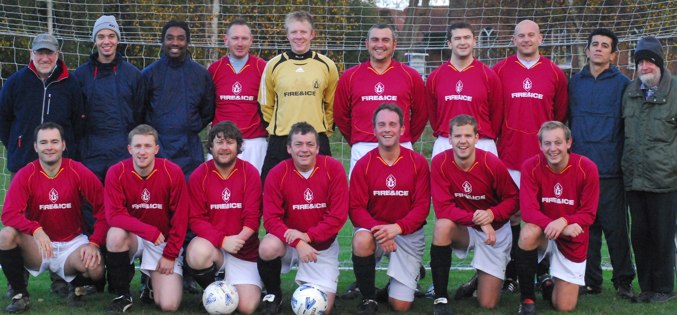
The Taverners reserve squad faces the camera:
Back row:
Bob Bullamore, Jamie Brittain, Mark Aldred, Andy lambert, Alex Smith, Daren Stevens, Bevan Burgess, Geoff Leeks, Tem Atabaky, Frank Fleming.

Front:
Eamon Mongan, Sam Burrows, Paul Ryan, Trevor Hollinsworth (player/manager), Matt Davis, Philip Bowman, Paul Strutt.

