TAVERNERS
News & Review

Issue 252 - December 2009 - e-version 1

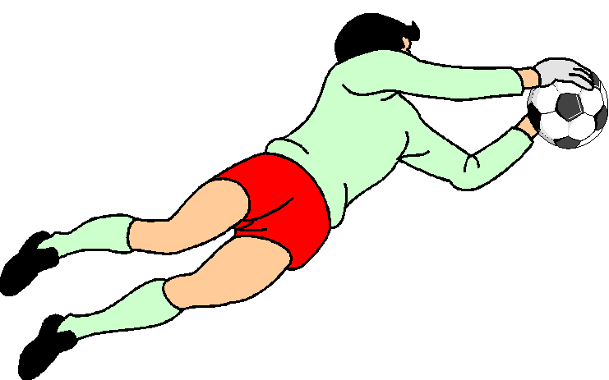

Club Sponsors: Fire and Ice

Website: www.tavernersfc.org.uk

TAVERNERS FOOTBALL CLUB

Established 1967

Members of the Ipswich Sunday Morning Football League since 1972
(Members of the Gippeswyk Sunday League 1967 - 1972)

Members of the Saul Charity Cup

Affiliated to the Suffolk County Football Association : No. GS100083

Colours:
1st team: White shirts, white shorts, black socks
2nd team: Yellow shirts, navy blue shorts, red socks

Home ground: Greshams Sports Club, Tuddenham Rd, Ipswich

Club Committee:

Chairman: | Pat Elvin | Tel: 748206
Vice Chairman | Bill Fleming | Tel: 742713
Secretary/1st team manager: | Bob Bullamore | Tel: 729586
Treasurer: | Gary Pilkington | Tel: 01394 386686
2nd team manager | Trevor Hollinsworth | Tel: 07802176434
Officers | James Bullamore | Tel: 07917185487
 | Bevan Burgess | Tel: 612693
 | Daren Stevens | Tel: 07979851887
 | Tom Brooks | Tel: 740868
 | Duncan Southgate | Tel: 07834614677

Club honours:

Taverners
News & Review

Issue no. 252 - 8 December 2009 - E. version 1

Looking back with the Tavs….from 5 to 40 years

5 years ago (October 2004)………The first team needed a tremendous fightback to finally beat Trimley Rangers in a Sunday Cup tie played at Greshams. Trimley built up a 3-0 lead only to see this wiped out by goals from James Rice, a Tom Brooks header and then a close-range effort from Trevor Hollinsworth. Trimly came back to take the lead again at 4-3 only for James Bullamore to power in the equaliser and then Gary Pilkington provided the opening for Paul Strutt to sweep through and round the keeper for a dramatic winner.

Another fightback was required – this time only from a single-goal deficit – for the Tavs to beat Colonials 3-1 in a Senior Cup 2nd round tie. The Taverners goals came from Daren Stevens and Ashley Watson 2.

The month ended with a hard-fought match against Ipswich Hospitals at St. Clements Hospital which ultimately ended in a 2-0 defeat.

The reserve team exited the Sunday Shield, losing 3-2 to Trojans at Rushmere Sports Centre. We trailed by three goals before Tony Monaghan and Paul Strutt reduced the arrears.

The following week the two teams met again – this time in the league – and the Tavs won by 5-4.

Goals from Gary Cunningham 2, Ray Sherman 2 and Mike Ray saw Taverners 5-2 ahead then – in the words of the Taverners News & Review of the day……”the last 15 minutes saw the Tavs under pressure against a strong wind and we conceded two silly goals from free-kicks. It took a great save from Daren Warner and a tremendous last-ditch tackle from Matt Parker to ensure we retained our lead.”

A home match against Jacob Bailey followed and, unfortunately, the Tavs’ teamsheet showed nine changes and a bare eleven on duty. Paul Strutt scored the Taverners goal in a 2-1 defeat.

Early in October a presentation match was played under the Ipswich wanderers floodlights to celebrate the achievements of Bevan Burgess, Gary Cunningham, Andy Spivey and Daren Stevens in respectively playing their 400th games for the Club.

The current squad beat a mature Xl by 4-0 and the game was followed by refreshments in the bar. Elvin King covered the event in the Evening Star under the headline ‘Loyal Family.’

10 years ago (October 1999)……After leading through Mike Cura against Kirton United in the Sunday Cup, the Tavs allowed our opponents back into the game and eventually saw Kirton equalise just before the break and go on to net a late winner.

The 1st team made their exit from the League Senior Cup a week later, Hadleigh Goldstar netting two late goals in a match played in awful conditions at East Bergholt High School.

The reserves lost 2-1 to Pauls in the Sunday shield (Andy Bown scoring) and were then beaten 5-0 by Factair in the league. A 3-3 draw with Charsfield followed (Mike Ray 2 and Ray Sherman scoring the goals) but this result was wiped out of the league’s records when Charsfield later withdrew.

We then beat Dickerson reserves 6-1 in the Reserve Cup with goals from Paul Oakshott 2, Andy Bown, Ray Sherman, Tim Howard and Paul Ryan.

15 years ago (October 1994)……The 1st team’s second league match of the season ended in a 5-1 home defeat by St Clements (Andy Glover scoring) but we bounced back to beat Felixstowe TLC by the same score, again at home. Mark ‘Bubble’ Smith, Paul Oakshott 2, Pat Elvin and Trevor Hollinsworth scored the Taverners goals.

A 4-2 defeat at the hands of Norbridge (away) followed, Andy Glover and Trevor Hollinsworth netting for the Tavs.

The reserves began October with a 4-1 home win over PCS in the Sunday shield, Gary Cunningham 2 and mike Ray scoring for the Tavs. Gary’s first goal represented his 100th goal for the Club, scored in 210 appearances.

They followed this with another 2-1 win away to The lion, Robert Parker and an own goal registering for Taverners but the month ended with a 2-1 defeat at the hands of Monks Eleigh; Bevan Burgess scored for the Tavs.

20 years ago (October 1989)……..The first team began the month with a difficult Sunday Cup 1st round tie away to Division 1 side Heathfield and gave a fine performance, drawing 0-0 after extra - time. No penalty deciders in those days, of course!

Unfortunately, there was no second chance as Heathfield won the replay 3-0 at Cranes. We bounced back with a 2-1 win over Melton YCOB reserves (away) by 2-1, Daren Stevens (penalty) and Bevan Burgess scoring the Tavs goals.

The month ended with a hard-fought game against Hadleigh Goldstar at Hadleigh High school. Hadleigh led for a long period but Kevin Oxborrow equalised for Taverners, only for Hadleigh to grab a late winner.

The reserves’ disappointing run continued with a 2-1 home defeat at the hands of Belstead Exiles (Bevan Burgess scoring) and a visit to Holbrook Rovers again saw the Tavs beaten 2-1. Danny Jay scored the Taverners goal, while the goalkeeping crisis saw Pat Elvin volunteer to appear between the sticks despite being on the Club’s injury list.

October ended with the Tavs being knocked out of the League Reserve Cup, Ipswich Postals reserves winning the 1st round tie 2-0.

25 years ago (October 1984)……. It was cup action almost all the way for the 1st team, beginning with a 1-1 draw away to Division 1 side Felixstowe Harpers, Pat Elvin scoring the Taverners goal. The replay saw the Tavs win a typical cup encounter 2-0 with goals from Glen Parker and Steve Nunn.

Another cup match followed, against Haven Ports in the Sunday Cup. The Ports scored first and, despite Taverners’ pressure, it was not until deep into injury time that Chris Lushington equalized. Chris and Steve Nunn found the net in extra time to give the Tavs a well-deserved 3-1 victory.

Club captain Pat Elvin missed the game through injury……thus ending a remarkable run of 175 consecutive appearances!

We followed this with a 5-0 league win over Felixstowe Dock Athletic, Steve Nunn, Terry Pilbro, Elwyn Goulding 2 and Glen Parker scoring our goals.

The reserves began October 1984 with a disappointing 4-2 reverse at the hands of Park Vale. Chris Cazey and an own goal scored our goals. We then lost by the same scoreline to Holbrook Rovers reserves, the Tavs goals coming from Ian Scott and Paul Smith.

An improved display against Bucklesham wanderers saw Taverners always in the hunt but defensive errors saw us lose 3-2. A spot-kick from Daren Stevens and a Dave Brennan goal registered for the Tavs.

The reserve team then gave a good display against Holbrook Rovers reserves in the Reserve Cup and we won by 4-3 with goals from Kevin Smith, John Burrows, Elwyn Goulding and an own goal.

30 years ago (October 1979)…….The senior side won a League KO Cup 1st round tie at home to Sutton United by 4-2 with goals from Alan Bultitude, Mick Flude 2 and Paul Miller and then beat ABT Plastics 5-0 in the Sunday Shield. Our scorers were Pat Elvin 2, Glen Parker 2 and Bill Ormsby.

Returning to league action, Taverners beat Rampant Horse (a) in very heavy conditions, Paul miller, Pat Elvin, Mick Flude and an own goal netting for the Tavs. Sutton United were our visitors in the league and they were only beaten by a last-gasp Glen Parker goal.

Our earlier scorers in a 3-2 scoreline were Glen (with a penalty) and Paul Miller. The month ended for the first team with a 4-2 win in the League KO Cup against Snowflake Insulations. Alan Bultitude, Cecil Pittock, Paul Miller and Mick Flude scored the Taverners goals.

The reserves beat Co-op reserves 7-2 with goals from Louis Newman 2, Brian Palmer 3 and Keith Newman 2. Brian weighed in with two more as Park Vale were beaten 5-2, our other scorers being Chris Potter 2 and Bill Ormsby.

A friendly against Debenham followed, Taverners winning 7-3 with goals from Steve Baker 3, Louis Newman 2 and Chris Potter.

A top-of-the-table clash with Sproughton Wild Man saw Taverners lead 2-1 (through Bill Ormsby and Louis Newman) with only 15 minutes left but we let the points slip as two late goals were conceded.

35 years ago (October 1974)…...Our Sunday shield replay with Kesgrave Exiles saw Kevin Stevens play his last game in goal for the Tavs before his move to top division 1 side Bentley (MA) United and ‘the cat’ had a marvellous game, inspiring the side to a 5-3 win. Our goals came from Paul Miller 2, Mick Flude 2 and Chris sefton.

We followed this with a 5-1 win over GRE reserves, our goals coming from Colin Last, Paul Miller, Mick Flude, Chris Sefton and John Davey but a point was dropped a week later when a somewhat spectacular o.g. gave Somersham a 3-3 draw. Colin Last, Paul Miller and Mick Flude scored for Taverners.

40 years ago (October 1969)….. We began the month with our fourth Gippeswyk League defeat from four outings – losing 2-0 to Manor House at the old YMCA ground at Bourne End (long since built on!) For reasons long forgotten, the game was played without goal-nets – unthinkable nowadays!

At last a victory improved our spirits, Hollesley United being beaten 3-2 at Woolverstone on a bright afternoon. Bob Bullamore – with a delicate chip over the advancing keeper (the editor can remember every detail of the few goals he scored!) – Martin Buck and Mick Prentice scored the Taverners goals.

We were then beaten 7-1 at home by Manor House. Ross Turtill scored the Taverners goal.

Pilky’s 300 appearances
The reserve team’s visit to Hadleigh Goldstar might have ended in defeat but it was still a ‘red-letter’ day for Gary Pilkington who was playing his 300th game for the Club (111 1st team & 189 reserves).
Pilky is pictured receiving a memento from reserve team manager Trevor Hollinsworth to mark this fine achievement.
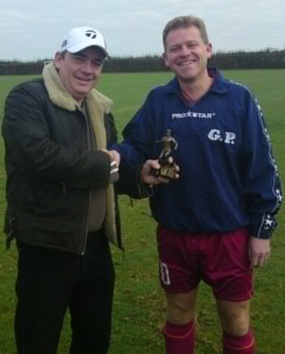

Looking back with the Tavs
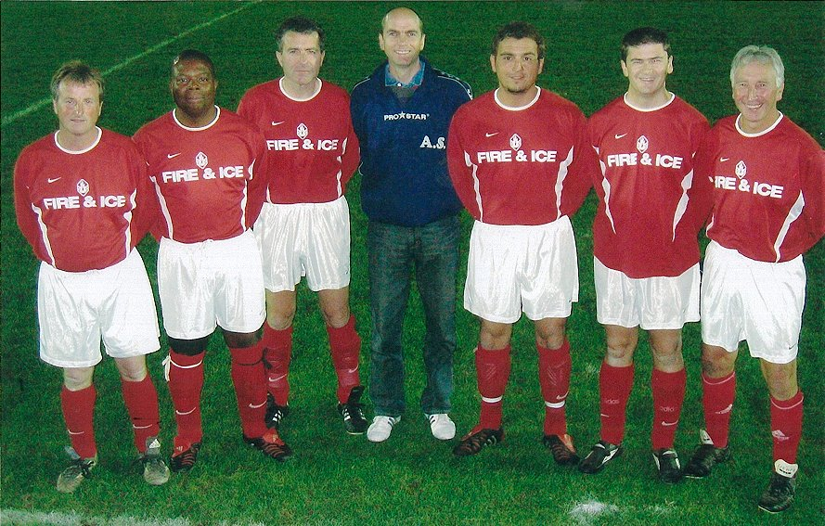
5 years ago: The Tavs staged a celebration match to mark the achievements of Bevan Burgess, Gary Cunningham, Andy Spivey and Daren Stevens who had played their 400th games for the club, They are shown with the other ‘400-plus’ men, Trevor Hedges, Tim Howard and Pat Elvin.

10 years ago:
Mike Cura was on target for the 1st team in October 1999 against Kirton United in the Sunday Cup.

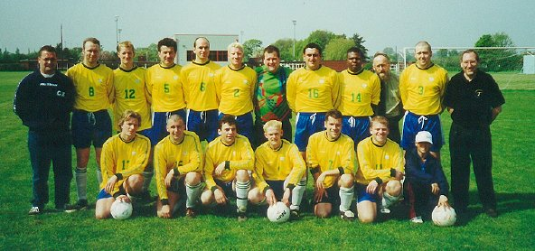
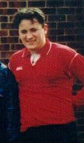
15 years ago: Robbie
Parker scored for the reserves
In their 2-1 win over The Lion.

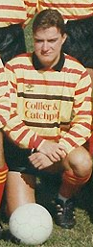

20 years ago: Kevin Oxborrow scores
For the Tavs in a 2-1 defeat against Hadleigh Gold Star.

Looking back with the Tavs

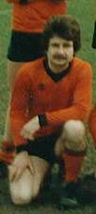
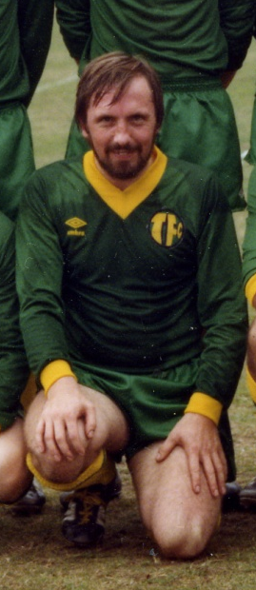
25 years ago: Kevin Smith scored a rare goal as the reserves beat Holbrook Rovers reserves 4-3 in the League Reserve Cup in October 1984.

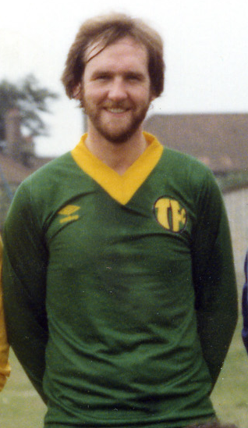

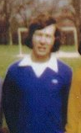
30 years ago: Cecil Pittock (left) and Alan Bultitude are on target as the Tavs 1st team beat Snowflakes Insulations 4-2 in the League KO Cup in 1979

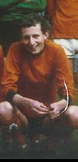
40 years ago:
35 years ago: Colin Last was on the scoresheet
In October 1974 as the Tavs beat
GRE reserves 5-1 at what is now
the Greshams Sports Club.

40 years ago: Martin Buck scored for Taverners in 1969 as Hollesley United were beaten 3-2 at Woolverstone.

First team focus - Bob Bullamore reports
This one could have gone either way.........................................Ferryboat 2, Taverners 2
The Taverners 1st team and Ferryboat produced a fine game at Walton on Sunday - competitive but always played in good spirit. Shaking off the previous week's debacle, Taverners also refused to be shaken by a deflected shot which gave Ferryboat an early lead. We showed a determined and united approach to defend well and break into attack quickly.
A wonderful save by goalkeeper Marty Smith denied a second goal and the Tavs came into the match as an attacking force, a purple patch towards the end of the half seeing Jason Riley's pace and movement cause the Ferryboat defence distinct problems. We equalised with a superb dipping shot from Duncan Southgate from some distance out on the left.
Half-time interrupted our rhythm and Ferryboat regained the initiative afterwards, grabbing the lead within a few minutes. Marty Smith and his defenders had to show great commitment but again Taverners fought back and a break forward by James Bullamore gave Liam Claydon the opportunity to burst through for a coolly-taken equaliser.
The closing minutes saw both teams go close but a draw was a fair result of a game which was enjoyable to play in and exciting to watch.
Team: Smith, Beaney, Bullamore, Jacobs, Cunningham, Southgate, Brooks, L. Riley, Keavey, Claydon, J. Riley.

Another solid point.........................................................Taverners 1, AFC Woodbridge 1
The 1st team entertained AFC Woodbridge at Greshams and showed a repeat of the determined approach they had demonstrated the previous week.
The nearest either side came to a goal in a tough first half battle was an effort from Taverners' Jason Riley which hit the bar.
We welcomed fit-again centre half James Horsfall back into the side and he hit the post with a far post header. Eventually, the Tavs went ahead midway through the second half when Sam Burrows - playing his first game of the season for the 1st team - produced a superb cross and Jason Riley got behind the defence to head home.
Unfortunately, the lead was short-lived as Woodbridge equalised through a Taverners own goal from a corner. Taverners enjoyed the better chances as the game drew to an end but we were also grateful to goalkeeper Marty Smith for a finger-tip save onto the bar with virtually the final action to secure a point.
Team: M Smith, Beaney, Bullamore, Horsfall, Cunningham, Burrows, L Riley, Brooks, Southgate (Sub: Brittain), J Riley, Claydon

Solid display brings first win......................................................Hadleigh RBL 3, Taverners 7
The 1st team secured a confidence-boosting win on Sunday, building on two drawn games to beat Hadleigh RBL 7-3 away.
In an even start, Hadleigh took the lead when a cross-cum-shot drifted in but Taverners fought back and a superb chip from Lee Riley brought an equaliser. Then a 20 yard volley from Duncan Southgate put the Tavs
2-1 ahead.

Lee Riley's corner was met by a towering header from James Horsfall for a 3-1 interval lead and Taverners made the ideal start to the second half when James Bullamore netted a penalty after a handling offence. Gary Cunningham produced a great through-ball which sent Liam Claydon away to add a fifth goal and then a superb move and run by Claydon gave the lively Lee Riley the chance for his second goal which gave Taverners a 6-1 lead.
Hadleigh continued to press forward and they reduced the arrears only for Tom Brooks to crash the ball in after a goalmouth scramble. Another Hadleigh goal finished the game 7-3 in the Tavs favour, a fine performance.
Team: M Smith, Beaney, Bullamore, Horsfall, Cunningham (Sub: Chard), Southgate, Brooks, Keavey, Pilkington, L Riley, Claydon (Sub: Atabaky).
Tavs edged out on penalties after thriller..Tavs 3, Whitton Maypole ’88 3 (Whitton win 4-3 on pens)
Determined to shake off memories of a Sunday Cup drubbing only a few weeks ago, Taverners adopted a tight-midfield approach And had the boost of an early lead when Tom Brooks headed in Lee Riley's corner.
Whitton came back and equalised midway through the first half via a free-kick. A close range effort from the raiding Tom Brooks restored the Tavs' lead but a Whitton penalty levelled the scores again.
It was the Maypole who took a 3-2 lead in the second half with a shot from the edge of the box but back came Taverners and a deft back-heel from Liam Claydon played in Tom Brooks and he swept the ball home from an angle to complete a fine hat-trick and make the score 3-3.
Tom was always involved in Taverners' attacking action and might have scored a fourth as we went close more than once during extra time. At the other end, Whitton hit the bar for a second time while Tavs goalkeeper Marty Smith made two smart saves.
30 minutes' extra time couldn't seperate the teams but Whitton Maypole emerged from the subsequent penalty decider 4-3 winners to progress to the next round.

Team: M Smith, Beaney, Bullamore, Jacobs, Cunningham, Southgate, Claydon, Brooks, Keavey, L Riley, J Riley

A thrilling win for the Tavs........................................................Taverners 2, Capel Plough 1
The 1st team knew that Capel Plough - unbeaten so far - would be tough opposition but, once again, our attitude was good right from the start, even when we had to defend some Capel pressure in the early stages.
When Taverners counter-attacked, we stretched the Capel defence and we grabbed the lead when Lee Riley's well-judged pass saw brother Jason speed away and round the keeper in style before firing home.
Capel came back and Marty Smith once more showed his class with a tip-over from a fierce shot. Capel weren't to be denied and they equalised when a free-kick move was half-blocked and a forward reacted first to force the ball home.
The Tavs had found the wind-advantage in the first half a mixed blessing as, too often, the ball ran away from the forwards and Capel were similarly frustrated after the break.
Goalkeeper Smith saved well again and, midway through the second half, Taverners regained the lead when Duncan Southgate jinked in from the left and pulled the ball back for Tom Brooks to fire high into the net.
Although Capel pressed forward, the Tavs defence - well-marshalled by 'Panda' Jacobs - stood firm. Further forward, everyone put in great effort and Brooks' goal proved to be the winner in a sporting match.

Team: M Smith, Beaney, Bullamore, Jacobs, Cunningham, Southgate, Lambert, Brooks, Keavey, L Riley
(Sub: Gledhill), J Riley
Who cares about the rain? – Tavs clinch the points....Martlesham Old Boys 1, Taverners 4
In common with everyone involved in Sunday Football, Taverners and opponents Martlesham Old Boys encountered severe weather conditions at Nacton Stadium but the match was a sporting affair and credit goes to all concerned, including referee Chris Holmes with a particular mention for David Vincent who ran the line for the Tavs and unused subs Julien Holmes and Vaughn Gledhill for their support.
The Tavs were quickly brought down to earth after their fine win the previous week - conceding an early goal from a Martlesham corner.
Both teams had their moments during the rest of the first half, the crossbar being struck at each end while Andy Lambert produced a superb last-ditch tackle as Martlesham threatened. Taverners finally equalised just before the break with a forceful far-post header from Adam Beaney from Lee Riley's corner.
The second half saw the Tavs press forward and they took the lead with a fine move which ended with Lee Riley's pass releasing brother Jason to fire home.
A number of Taverners chances went astray and these might have proved costly as Martlesham produced several dangerous crosses and forced Marty Smith to save well.
A third Taverners goal was decisive, Jason Riley firing high into the far corner from long range and then neat play by Mike Cura gave Tom Brooks the chance to round the scoring off at 4-1.

Team: M Smith, Beaney, Bullamore (Sub: Cura), Jacobs, Cunningham, Southgate, Lambert, Brooks, Keavey,
L Riley, J Riley
Tavs secure points despite missed chances..................Taverners 1, Martlesham Old Boys 0

The 1st team entertained Martlesham Old Boys at Greshams in conditions which were in complete contrast to the wind and constant rain encountered when the teams met last week at Nacton.
The first match had been competitive but mainly fair and this spirit characterised the return.
Taverners pressed early on and stretched the visiting defence with some fine runs, taking the lead after 12 minutes when two efforts were half-blocked only for the persistent Tom Brooks to pounce and force the ball home. Tom became leading scorer with 7 goals from 9 appearances – a great return for the midfielder.
Several more chances were created and wasted by hurried finishing and when the Tavs produced shots on goal they found the Martlesham goalkeeper in fine form. Tom Brooks saw one effort tipped over while Liam Claydon had a shot in each half well saved.
Although still the more incisive team after the break, the Tavs didn't enjoy nearly as much possession as before and there was always the worry that Martlesham would grab an equaliser. They missed one good chance but Taverners worked hard throughout the side and ran out winners courtesy of Brooksy's early goal.

Team: M Smith, Beaney, Jacobs, Lambert, Cunningham, Pilkington, Claydon, Brooks, Southgate, L Riley, J Riley
Kirton too good overall............................................................Kirton United 4,Taverners 0

The first team travelled to top-of-the-table Kirton United on the back of a run of good results - undoubtedly our best-ever in the top flight - and the early stages, on a surpisingly firm pitch despite the recent rain, suggested an even game.

Our good form has been based on a tight midfield line-up and it was, therefore, disappointing that a strong individual run from a deep position cut through us so easily to give Kirton the lead. Goalkeeper Marty Smith had already made one good save and on another occasion he did well to reach a loose ball first and smother it after Kirton had hit a post.

Kirton made the score 2-0 but we had been in the game ourselves; Tom Brooks had seen one header go over the bar and then, just before half-time, Lee Riley stabbed a shot against the near post after a good build-up. The first ten minutes of the second half saw the Tavs' best period but Kirton were exceptionally quick on the break and a defensive mistake led to a third goal which pretty well killed the game.

To our credit, we continued to work hard even when the home side scored a fourth near the end but our final approach-work was too often crowded out by a strong defence while, on other occasions, our final passes went astray. We relied on Marty to make further good saves throughout. It was good to see Ryan Horsfall back in a Taverners shirt after his year 'down under.'

A surprise visitor - who we were delighted to see (courtesy of the Tavs' website information on the fixture) - was Mark Moore, a goalkeeping stalwart for many years and a member of our Division 2 Championship side in 1994, on a flying visit from his Lancashire home. A pity we couldn't produce a better result for him to enjoy!

Team: M Smith, Beaney, Jacobs, Lambert, Cunningham (Sub: R Horsfall), Keavey, Claydon, Brooks, Southgate,
L Riley (Sub: Aldred), J Riley

Taverners FC
current appearance & goalscoring stats
- season 2009/10 -

1st team appearances |  | 2nd team appearances |  | 1st team goals
A Beaney | 10 | E Mongan | 11 | T Brooks | 7
T Brooks | 10 | J Brittain | 10 | J Riley | 5
G Cunningham | 10 | R Fisk | 9 | L Claydon | 2
L Riley | 10 | M Webb | 9 | L Riley | 2
J Riley | 9 | P Bowman | 8 | D Southgate | 2
D Southgate | 9 | V Gledhill | 8 | A Beaney | 1
J Bullamore | 8 | J Holmes | 8 | J Bullamore | 1
M Smith | 8 | T Atabaky | 7 | J Horsfall | 1
L Claydon | 7 | A Lambert | 7 | Total | 21
A Jacobs | 7 | G Pilkington | 7
C Keavey | 7 | M Aldred | 6 | 2nd team goals
A Lambert | 4 | B Burgess | 6
H Chard | 3 | T Hollinsworth | 6 | G Pilkington | 4
G Pilkington | 3 | A Smith | 6 | P Bowman | 2
B Burgess | 2 | P Strutt | 6 | J Brittain | 2
J Horsfall | 2 | J Valentine | 6 | A Lambert | 2
D Stevens | 2 | S Burrows | 5 | P Strutt | 2
M Aldred | 1 | K Dawson | 5 | T Atabaky | 1
T Atabaky | 1 | M Cura | 4 | H Chard | 1
J Brittain | 1 | A Spivey | 4 | M Cura | 1
S Burrows | 1 | M Smith | 3 | V Gledhill | 1
L Farris | 1 | D Stevens | 3 | T Hollinsworth | 1
V Gledhill | 1 | T Brooks | 1 | E Mongan | 1
R Horsfall | 1 | G Cunningham | 1 | D Stevens | 1
S Kidby | 1 | R Horsfall | 1
M Cura | 1 | L Wiggins | 1
Possible | 10 | Possible | 11 | Total | 18

Reserve Scene - Trevor Hollinsworth reports

Tavs struggle to keep visitors out....................Taverners reserves 3, Aldeburgh associates 5
Visitors Aldeburgh Associates began the sharper team and soon took the lead.
The Tavs equalised with a cross-cum-shot from Mike Cura after good build-up work wide on the left. Unfortunately, Aldeburgh were quickly in front again but Taverners equalised via a fine rising shot into the top corner from Gary Pilkington.
Towards the end of a see-saw first period, Aldeburgh regained the lead and then extended this somewhat controversially to go 4-2 up with the last kick of the half.
The second half was a much quieter affair with the Tavs pushing forward to try and get back in contention but not quite finding a way through. A goalmouth scramble saw Gary Pilkington grab his second goal to reduce the arrears before a breakaway move sealed a 5-3 Aldeburgh win.
Team: Stevens, Lambert, Dawson, Bowman, Burgess, Brittain, Mongan, Cura, Pilkington, Aldred, Strutt (Subs: Atabaky, Valentine).

An enjoyable country outing..............................................Alderton 1, Taverners reserves 5
Taverners have always done well and enjoyed trips to smaller villages where there is normally a good vocal local crowd. Alderton did not disappoint.
Apart from the non-existent dressing room it was a beautiful sunny morning, a good pitch and a very well run village team. After the disappointment of losing the previous week it was made very clear to the team that today could not be another disappointing result.
The opening exchanges were a little in Taverners favour with Eamon Mongan and Gary Pilkington controlling midfield. The addition of Andy Spivey in at left back also proved a big hit. Taverners took the lead on 20 minutes when Paul Strutt found himself clear to score.
The second came just a few minutes later when Eamon Mongan fought well in the box to chip the keeper from close range. Alderton still pressed but their attacks were halted by a solid defence.
Just before half time Taverners added a third when Eamon put ‘Dippy’ Bowman through and he easily beat the on coming keeper.
For a period of time in the second half Alderton made some headway attacking on our flanks causing some problems and were rewarded with a goal. Undaunted Taverners pressed harder. They regained the three goal advantage when Daren Stevens headed in from ten yards. This effectively killed off the game and Alderton were easily contained for the remainder of the match. Taverners added their fifth when Andy (Skip) Lambert headed home from a corner.

So the first league win of the season and on this form not the last.
Team: A Smith, Fisk (Sub. Holmes), Webb, Lambert, Spivey, Bowman (Sub: Aldred), Pilkington, Mongan, Burgess, Stevens, Strutt (Sub: Atabaky)
Tavs second best to Holbrook Swan.............. Taverners reserves 1, Holbrook Swan 4
Taverners reserves entertained high-flying Holbrook Swan at Greshams and, as last year, found our ex-Licensed Trades League opponents tough opposition.
While we were pleased to see Holbrook’s manager Martyn O'Leary and reflect on his many years as a Taverners stalwart – and a veteran of several trips to Belgium - we were unable to repeat our good performance at Aldreton and finished the game itself second-best, losing 4-1 in a hard-fought match.
Vaughn Gledhill scored the Taverners goal.
Team: A Smith, Gledhill, Webb, Lambert (Sub: Holmes), Spivey, Bowman (Sub: Valentine), Mongan, Dawson, Fisk, Stevens, Brittain (Sub: Hollinsworth).

Tavs’ Sunday Shield run goes on........................Felixstowe Dolphins 1, Taverners reserves 4
With the Taverners 1st team having made an early exit from the Sunday Cup, all eyes were on the reserves on Sunday in their Sunday Shield (round 2) visit to Felixstowe Dolphins.

After both teams had shown their attacking paces early on, the Tavs grabbed a 10 minute lead, Tem Atabaky threading the ball through and 'Dippy' Bowman coolly beating the advancing keeper. Within a few minutes, Tem was on the Taverners scoresheet, latching onto a loose ball in a crowded goalmouth to head home and then Jamie Brittain found the net to give us a 3-0 lead after only 25 minutes play.

Any thoughts of an easy win were short-lived. The Dolphins had produced some useful attacks and another of these saw them reduce the arrears before half-time.
The next goal was clearly going to be vital and, once again, both teams had their moments. Taverners goalkeeper Alex Smith blocked a 'one-on-one' situation while the outstanding Andy Lambert made a superb last-ditch tackle on another occasion. Then a tremendous Tavs attack ended with Sam Burrows crossing for Gary Pilkington to head home for a 4-1 final score.
The 3rd round draw sees the Tavs reserves 'on the road' again - facing a trip to Corton White Horse Seltic in the shadow of Pleasurewood Hills on 1st November.
Team: A Smith, Fisk (Sub: Holmes), Webb, Lambert, Spivey, Bowman, Mongan (Sub: Burrows), Gledhill, Brittain (Sub: Valentine), Atabaky, Pilkington.

Pilky’s 300th but little else to cheer..........Hadleigh Goldstar Athletic 7, Taverners reserves 1
Gary Pilkington made his 300th appearance for the Tavs and before the game was presented with a momento by team-boss Trevor Hollinsworth. The trophy duly collapsed and was replaced the following week – your achievement deserved one that lasts just a bit longer, Pilky!
Turning to the game itself, it is hard to put into words where it all went wrong. It is true to say a number of players did not play to their full potential. It is true to say that individual errors put the game beyond us by just after half time. Taverners started well enough playing 5 across the midfield. But two errors before half time put us 2-0 down. Tav's should have scored just before the break when Gary Pilkington had a close range shot cleared off the line. Eamon Mongan fired in the rebound to be cleared again.
Hadleigh are without doubt the best team we have played this season but still it was frustrating that if we were on our game we would have kept the game very close. The most disapointing thing was some peoples
attitude to the game. Two more goals just after half time put the game beyond any revival. Taverners did however have a 20 minute spell of pressure at 5-0 and were awarded a penalty with 20 minutes to go. Andy
Lambert put the penalty away well. Hadleigh always seemed to have an extra man available and increased their lead before the last whistle to 7-1.

Team: A Smith, Gledhill (Sub: Atabaky), Lambert, Webb, Holmes (Sub: Cura), Burrows, Dawson, Mongan, Burgess, Pilkington, Brittain (Sub: Aldred).

Tavs can’t blame long trip for Shield exit..Corton White Horse Seltic 4, Taverners reserves 2

After an early start with such a long trip, Corton being on the northern edge of Suffolk near Lowestoft, It would be nice to blame the journey for the very poor start to the game. Within minutes Taverners were 2-0 down.
However, the journey was not the problem. Both goals came from player error. Then you could say conditions were a little extreme. A gale force wind and driving rain did not make it any easier but both teams had to cope with the weather. The fact that the whole of the Corton team and management called the referee by his christian name (which was Norman by the way) was a little bit of a worry. But it has to be said that, although he might not have been the best referee, he was in the main fair.
So after the shock of the first 10 minutes, Taverners did start to assemble some composure. They were not however keeping possession and Corton were controlling large areas of the pitch. So it was with some relief when Taverners pulled a goal back through Paul Strutt when he took control of the ball just inside the opposing half. He then beat two players before shooting from 20 yards.
After some strong words at half time Taverners did actually start to take some control of the game. Another reason for losing the game would be that Corton were just too good but this was not the case. Eamon Mongan and Gary Pilkington both made good progress against the Corton midfield. With the rain now battering the players, Taverners made changes bringing on all three subs in a ten minute period. But the changes only seemed to give Corton the upper hand and they went further ahead.
Taverners again rallied and began to press. The changes did begin to take affect and they pulled it back to 3-2 when a free kick was awarded 25 yards out. Trevor Hollinsworth hit a fierce shot which curled round the wall to beat the keeper at the far post. Taverners had chances to level the game through Gary Pilkington, Sam Burrows and Eamon Mongan but with just 10 minutes to go Corton sealed the result scoring probably the only goal they were not handed on a plate. It was disappointing because we knew on another day with all our normal players available we would have beaten a team like Corton easily.
Team: A Smith, Fisk, Valentine (Sub: Hollinsworth), Webb, Spivey, Burrows, Bowman (Sub: Aldred), Pilkington,
Strutt (Sub: Brittain), Mongan, Gledhill

Too many mistakes cost the Tavs dear.................Trimley Rangers 8, Taverners reserves 1

Reserve football does and always will throw you a few curve balls.

The 1st team is the priority and that often leaves you with a weaker side than you expected. However, it does not explain why we had to play on a school-sized pitch nor does it tell you why the team you are playing for the first time this season had all players available for selection. They are without doubt a very good side if their 1st eleven are there.

So with an experimental back four Tav's took the field. It is obvious and true to say that a number of players did not have their best game. Trimley took full advantage of that fact and raced ahead. Taverners were lost before half time and did not have the fire power to cope with Trimley. It has to be said that with no exaggeration that at least five of the goals were glaring mistakes by Taverners defence and not attacking play from Trimley.
The one consolation was probably the pick of the nine goals. One-touch football between Eamon Mongan to Jamie Brittain to Henry Chard who then fired from the corner of the 18yrd box to score. We will without doubt be there to battle again next week. It would just be nice if injuries and availability would go our way for once
this season.

Team: A Smith, Fisk (Sub: Valentine), Bowman, Gledhill, Holmes, Chard (Sub: Atabaky), Mongan, Brittain, Burgess, Strutt, Hollinsworth.

Chances go astray but Tavs come back for a point ......Taverners reserves 1, Lions Head 1

A fight-back shouldn’t have been needed by the reserves as they dominated their home match against Lions Head and missed a number of chances.

However, as so often happens, the team seemingly up against it grab a goal and Lions Head were delighted to go ahead in the first half. The Tavs came back and created more opportunities, Marcus Webb going agonisingly close when he broke through to beat the offside trap, only to hit the post.

The second half saw Taverners continue to battle on and a succession of corners from Bevan Burgess and Sam Burrows, who also crossed well, put Lions Head under more pressure.

Eventually, a good build-up on the right led to Jamie Brittain scoring the Taverners equaliser.

Team: A Smith, Fisk, Bowman, Webb, Burgess, Burrows(Sub: Holmes), Mongan, Strutt (Sub: Atabaky), Chard (Sub: Hollinsworth), Gledhill, Brittain

Tavs battle well against top-drawer opposition..........Taverners reserves 0, Ferryboat 6

The 1st team had no match on Sunday but the Tavs' reserves had virtually the most difficult tie they could have faced in the ISFL Senior Cup - at home to Premier Division Ferryboat.
Any doubts that the Tavs might have had about how hard their task was going to be were swept away from the kick-off as Ferryboat attacked straight away, scored early and were only prevented from adding to their lead by heroic goalkeeping from Marty Smith, some last-ditch defending and wayward finishing.
Gradually Taverners got to grip with things and battled very hard throughout the side, trying to play football on the break but still relying on Marcus Webb and Tom Brooks for great work in the middle of the back four. Two goals early in the second half put Ferryboat firmly in control and they scored three more times before the end despite the Tavs continuing to play with spirit and determination and never giving up.
The match was played in excellent spirit with little to worry referee Bob Wakeling who maintained full control.
Team: M Smith, Fisk, Webb, Brooks, Burgess, Brittain (Sub: Holmes), Mongan, R Horsfall (Sub: Atabaky), Pilkington, Aldred (Sub: Cunningham), Hollinsworth.

The Tavs 1st team face the camera

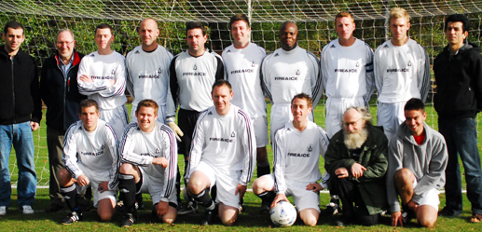
Back row: Liam Claydon, Bob Bullamore (manager), Jason Riley, Andrew ‘Panda’ Jacobs, Marty Smith, Chris Keavey, Gary Cunningham, James Bullamore, Tom Brooks, Tem Atabaky.
Front: Duncan Southgate, Adam Beaney, Andy Lambert, Lee Riley, Frank Fleming (vice chairman), Jamie Brittain.

This edition of the News & Review is being distributed as an ‘e-version’ for the first time and we hope this format is enjoyed by our readers.

What we never know, of course, is to what extent a ‘hard copy’ is picked up and snippets read over the days and weeks following its production but you can always print your own copy for that purpose if you prefer!

Printed copies are being dispatched to those members - and our supporters - for whom we don’t have email addresses, but it would be useful if an address could be sent to the editor - bob@bullamore.fsnet.co.uk - for future use.

Ongoing news - together with photos, results and reports - appear regularly on the club’s website - www.tavernersfc.org.uk - and we are very grateful to Bevan Burgess for keeping it up to the minute with all that’s going on.

We also contribute regular club notes to the Green’un at www.greenun24.co.uk.

The Ipswich Sunday Morning League website is also full of information - up-to-date league tables and results are easily accessible: see www.isfl.co.uk.

On the playing side, there has been a certain amount of fluidity with injuries, unavailabilities etc preventing the stability which would be ideal but they are facts of life in football. We have several players on the injury list and we hope to see them back in action as soon as possible.

Everyone should be aware that the club committee meet regularly and that ‘playing numbers/strengths’ are always high on the agenda and are matters which are addressed seriously and have priority over virtually everything else.

Both our teams have some vital matches ahead but the last two weeks have been disrupted by the bad weather which has caused so many postponements. We hope to see an improvement so that a fixture pile-up in the new year can be avoided.

Training at Copleston continues on Thursdays (from 8.00 to 9.00 pm). A £2 charge is payable from those taking part.

Finally, as this will be the last News & Review before Christmas, we send season’s greetings and a happy new year to all our members, supporters and readers.

 |  |  | Taverners FC Fixtures 2009/10
 |  | 1st team - Premier Div. |  | 2nd team - Div. 1 (RM)
Sept | 6th | Belstead Arms | a 0-3 | Chantry Blues | h 0-1
 | 13th | Whitton Maypole (S/Cup 1) | h 1-8 | Bramford Cock (S/Shield 1) | h 1-0
 | 20th | Ferryboat | a 2-2 | Aldeburgh Associates | h 3-5
 | 27th | AFC Woodbridge | h 1-1 | Alderton | a 5-1
Oct | 4th | Hadleigh RBL | a 7-3 | Holbrook Swan | h 1-4
 | 11th | Locomotive | h pp | Felixstowe Dolphins S/S 2 | a 4-1
 | 18th | Whitton Maypole (Sen Cup 1) | h 3-3 | Hadleigh Goldstar Ath. | a 1-7
 | 25th | Capel Plough | h 2-1
Nov | 1st | Martlesham Old Boys | a 4-1 | Corton W. H. S. S/S 3 | a 2-3
 | 8th | Martlesham Old Boys | h 1-0 | Trimley Rangers | a 1-8
 | 15th | Kirton United | a 0-4 | Lions Head Athletic | h 1-1
 | 22nd |  |  | Ferryboat (Sen Cup 2) | h 0-6
 | 29th | Belstead Arms | h pp | Chantry Blues | a pp
Dec | 6th | Whitton Maypole | a pp | Margaret Catchpole | H pp
 | 13th | Ferryboat | h | Aldeburgh Associates | a
 | 20th | AFC Woodbridge | a | Alderton | h
 | 27th | Hadleigh RBL | h | Holbrook Swan | a
Jan | 3rd | Locomotive | a | Fat Cat | h
 | 10th | Unicorn | h | Hadleigh Goldstar Athletic | h
 | 17th | Capel plough | a | Norbridge | h
 | 24th | Ascio | h | E & D Athletic | a
 | 31st |  |  | Trimley Rangers | h
Feb | 7th
 | 14th
 | 21st | Ascio 01/11 | a
 | 28th |  |  | Norbridge | a
 |  | To be arranged:
 |  | Belstead Arms | h | To be arranged:
 |  | Whitton Maypole 13/9 | h | Margaret Catchpole | a
 |  | Unicorn 18/10 | a | Fat Cat | a
 |  | Kirton United 22/11 | h | Chantry Blues | a
 |  | Locomotive 11/10 | h | Lions Head Athletic 22/11 | a
Apr | 4th | Easter |  | Easter

L
S
Brickwork Ltd.

M


LSM Brickwork Limited
Brickwork & Building Contractors
Tel/Fax (01473) 215321
Lee Smith (07904) 384242 (24 hrs)

