**Tavs' Topics – Christmas 2014**

**Taverners Football Club - established 1967 – affiliated to Suffolk FA**

**Members of the Gippeswyk Sunday League: 1967 – 1972**

**Members of the Ipswich Sunday Football League: 1972 onwards**

**The 2014/15 season so far:**

The first team have enjoyed a steady first half of the season which sees them set to compete in the ‘promotion part’ of the mini-league in the New Year but the reserves have had a difficult time – bearing the main brunt of the ‘numbers problem’ which is afflicting virtually every football team throughout the country.

However, we are determined:

* **to maintain two teams; and**
* **to bring on board more new signings so that we can reach the point where we have the right number of fully committed players to achieve this.**

We have already seen several new players join the Tavs in recent weeks and we hope they enjoy their football with us. Everyone can help by introducing more interested people.

At the start of the campaign, we set out the guidelines which we hoped everyone would follow and these are repeated, as follows:

* **Make yourself available to play as often as possible.**
* **Reply to texts with details of games straight away.**
* **Don’t ‘call-off’ for what might be perceived as a trivial reason. You might be leaving your team-mates to turn out with 10 men!**
* **Pay your match subs (£5) before the match. (A reduced amount of £3 is payable by job-seekers and full-time students.)**
* **Accept the fact that, on occasions, you might be substituted or have to start on the subs’ bench. We are all disappointed when this happens to us but “that’s football!”**

The experimental league structure saw each of our teams play in a six-team league and we have the following remaining fixtures, both on 4 January 2015:

**1st team** v. Kesgrave United (home) / **2nd team** v. Shotley Rose reserves (away)

Following those matches, the two parallel leagues will be re-formed with the top three teams in each division forming a new six-team league seeking promotion and the bottom three playing in a new division to avoid relegation.

One casualty has been Matt Davis following his serious knee injury sustained playing for the first team against Rushmere & Diamonds while James Horsfall has been sidelined through injury all season so far. We wish Matt and James all the best.

We were sorry to learn that Mark ‘Horsey’ Horsfall is unwell and our best wishes go to him, James and Ryan.

**Taverners FC – fixtures 2014/15**

|  |  |  |  |  |  |
| --- | --- | --- | --- | --- | --- |
|  |  | **1st team - Div. MB2B** |  | **2nd team - Div. MB3A** |  |
|  |  |  |  |  |  |
| Aug | 31st | Trinity | H 4-2 |  |  |
| Sep | 7th |  |  | Felixstowe Harpers reserves | H 1-3 |
|  | 14th | Lattice Barn (S/Shd 1) | A 3-1 | Shotley Rose reserves | H 2-5 |
|  | 21st | Cherrytree | A 6-0 |  |  |
|  | 28th | Westbourne W. (S/Shd 2) | H 1-9 | Kesgrave Kestrels (S/T 1) | A 1-5 |
| Oct | 5th | Kesgrave United | A 1-4 | Gladwells | H 0-10 |
|  | 12th | Trinity | A 0-5 | Thrasher United | H 0-7 |
|  | 19th | Rushmere & Diamonds | H 1-1 | Thrasher United | A pp |
|  | 26th |  |  | Felixstowe Harpers reserves | A 0-5 |
| Nov | 2nd | Rushmere & Diamonds | A 1-0 | Suffolk Punch | H pp |
|  | 9th | Bucklesham | H pp | Shotley Rose reserves | A pp |
|  | 16th | Cherrytree | H 5-5 |  |  |
|  | 23rd | Kesgrave United | H pp | Gladwells | A 0-9 |
|  |  | 1st team |  | 2nd team |  |
| Nov | 30th | Bucklesham | H 1-4 | Suffolk Punch | A 0-8 |
| Dec | 7th | Bucklesham | A 2-5 |  |  |
|  | 14th | Bucklesham (Junior Cup 1) | H 1-1 | Claydon Galaxy (Junior Cup 1) | A 5-12 |
|  | 21st | Christmas |  | Christmas |  |
|  | 28th | New Year |  | New Year |  |
| Jan | 4th | Kesgrave United | h | Shotley Rose res. | a |
|  |  | **FIXTURES IN THE NEXT MINI-LEAGUE START ON JANUARY 18th** |  | **FIXTURES IN THE NEXT MINI-LEAGUE START ON JANUARY 18th** |  |

## **Keeping in Touch**

This publication will be going to all current members together with our database of ex-players and supporters who we hope enjoy keeping in touch.

For complete up-to-the-minute detail – with photos and weekly updated stats and reports as well as features on ‘days gone by’ - do visit the Club’s website:

[www.tavernersfc.org.uk](http://www.tavernersfc.org.uk)



**First team Appearances 2014/15 (possible 12):**

A Cracknell 11, P Bestley 10, G Cunningham 9, M Davis 8, G Pilkington 8,

J Brittain 7, R Stanojevic 7, T Brooks 6, S High 6, D Stevens 6, J Bullamore 5,

R Fisk 5, C Keeble 5, G Leeks 5, M Sneddon 5, D Southgate 5, T Hollinsworth 4,

B Burgess 3, C Henry 3, D Herridge 3, C Parry 3, L Siggers 3, J Tacey 3,

B Derrett 2, B Hayward 2, R Horsfall 2, M Wray 2, M Buckley 2, W Lawrence 1,

G Palmer 1, D Spalding 1, P Strutt 1.

**First team goals 2014/15 (total 26):**

T Brooks 5, J Brittain 4, M Sneddon 3, D Stevens 3, C Henry 2, R Stanojevic 2,

R Horsfall 1, D Herridge 1, C Parry 1, J Tacey 1, G Pilkington 1, D Southgate 1,

Own goal 1

**Reserve team Appearances 2014/15 (possible 9):**

B Hayward 9, T Hollinsworth 9, B Burgess 8, J Bloomfield 7, D Herridge 6,

S Biss 5, J Holmes 5, N Sherman 5, P Strutt 5, G Leeks 4, G Pilkington 4,

A Baldwin 3, S High 3, R Sherman 3, D Stevens 3, D Warner 3, P Bestley 2,

J Bullamore 2, M Davis 2, A Hart 2, C Keeble 2, J Keeble 2, W Lawrence 2,

J Pinder 2, D Southgate 2, D Spalding 2, A Cracknell 2, G Cunningham 1, R Fisk 1, A Hunt 1, E Mongan 1, J Tacey 1, Whihall 1, M Wray 1

**Reserve team goals (total 9):**

B Burgess 3, T Hollinsworth 2, A Baldwin 1, D Stevens 1, N Sherman 1,

D Herridge 1

**‘Pilky’ makes it 400 appearances for the Tavs**

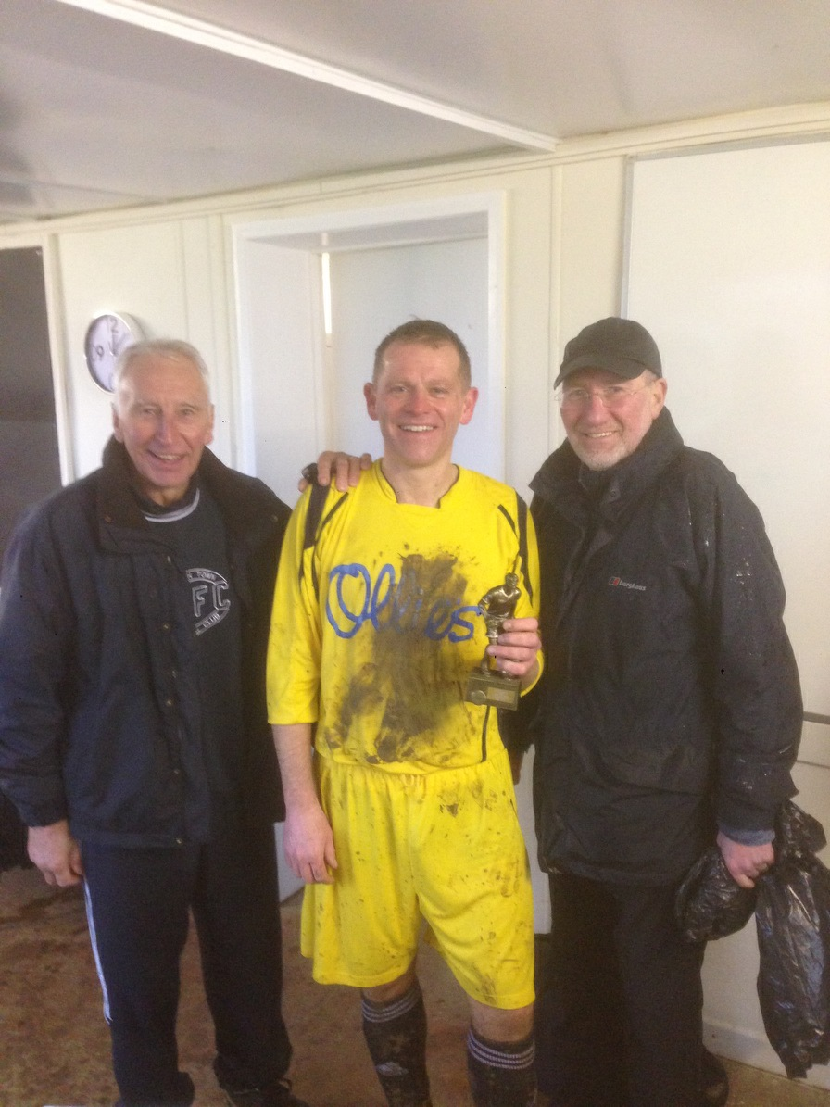

The reserve team’s match at Copdock against Gladwells represented Gary Pilkington’s 400th game for the Tavs and ‘Pilky’ is pictured after the match with a memento of the occasion flanked by Club Chairman Pat Elvin and 1st team manager Bob Bullamore.

**1st World War Commemoration**

On 25 December 1914 soldiers from both sides in the conflict put down their weapons in an impromptu cease-fire, with football being played and photographs taken for posterity.

Every club in the country, from the Premier League to grassroots have been asked to create a unique photographic record of football a century on from that First World War Christmas Truce.

Amongst them were the players of Bucklesham and Taverners, as shown below.

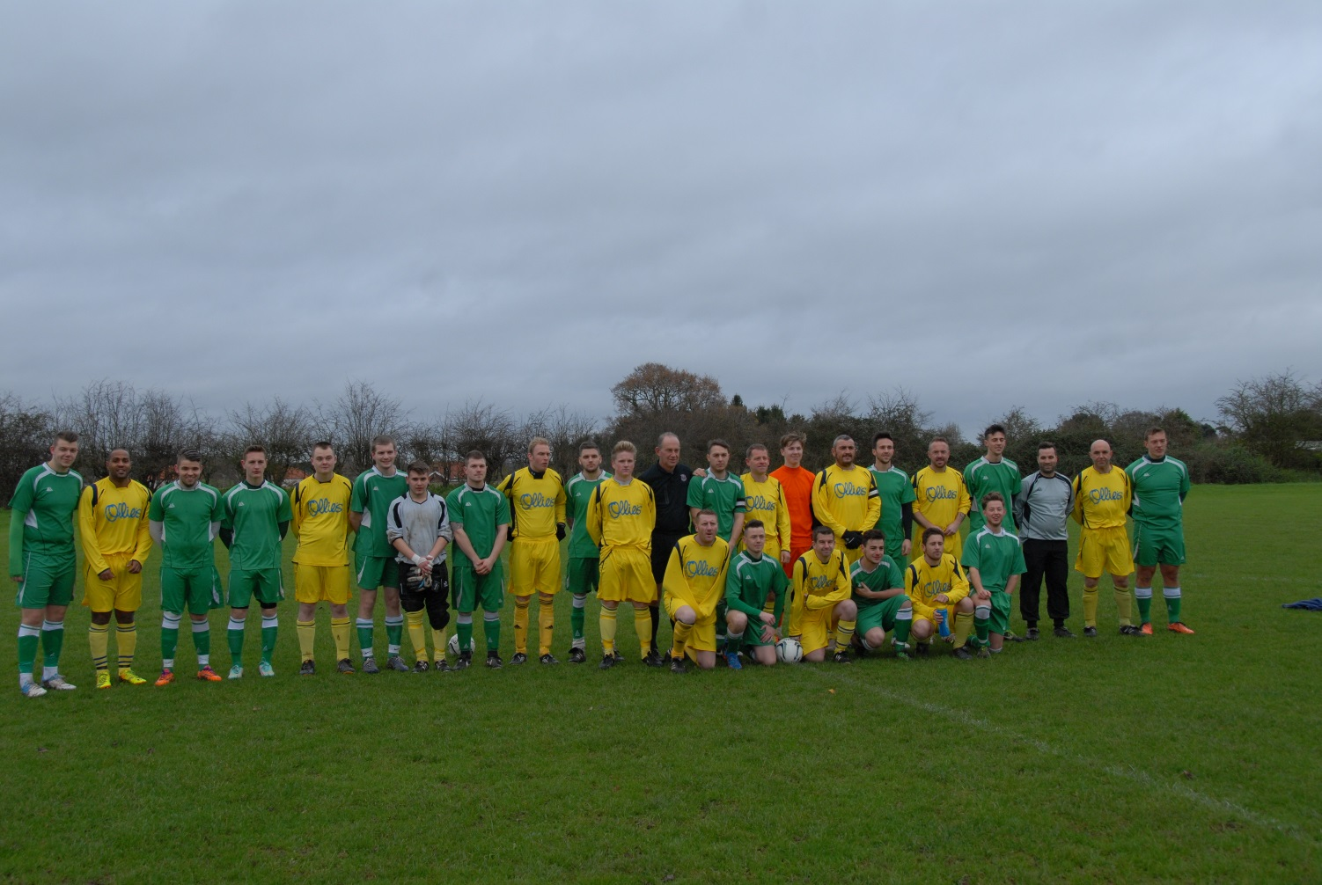

**The Tavs 1st team faces the camera**

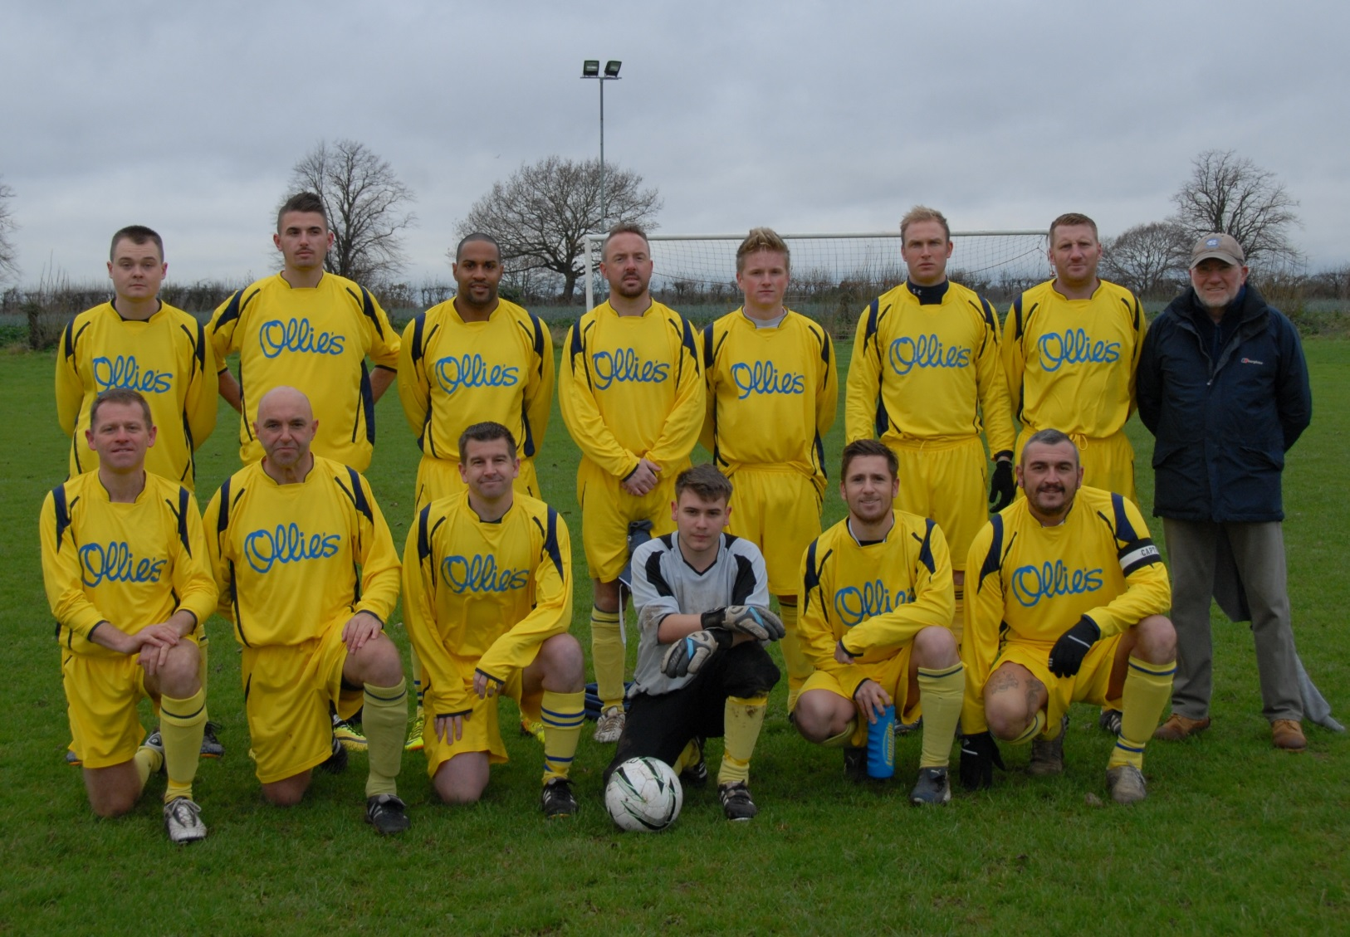

Back row: David Spalding, Rico Stanojevic, Marcus Buckley, Andy Cracknell, Jawa Tacey, Tom Brooks, James Bullamore, Bob Bullamore (manager).

Front row: Gary Pilkington, Paul Bestley, Duncan Southgate, Callum Keeble, Liam Siggers, Daren Stevens.

**The hat-trick men**

Although the first half of the season has seen the Tavs have mixed results to say the least, three of our players have scored hat-tricks: Jamie Brittain and Tom Brooks (in the 1st team’s matches against Cherrytree) and Bevan Burgess in the reserve team’s last match, away to Claydon Galaxy.

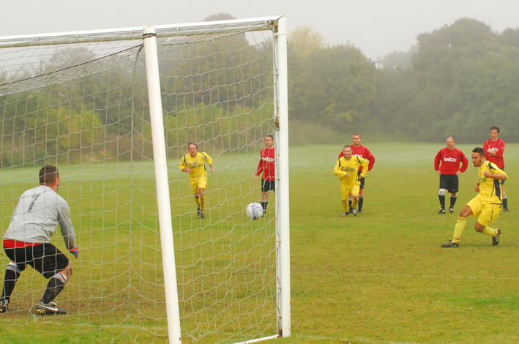

Jamie Brittain (left)

Tom Brooks (below)

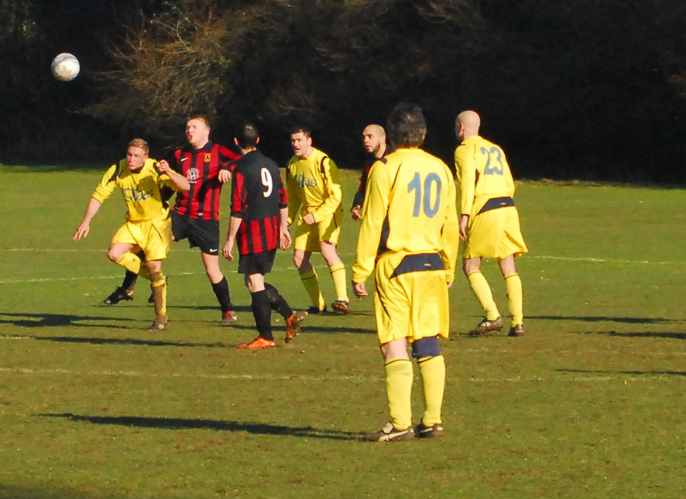

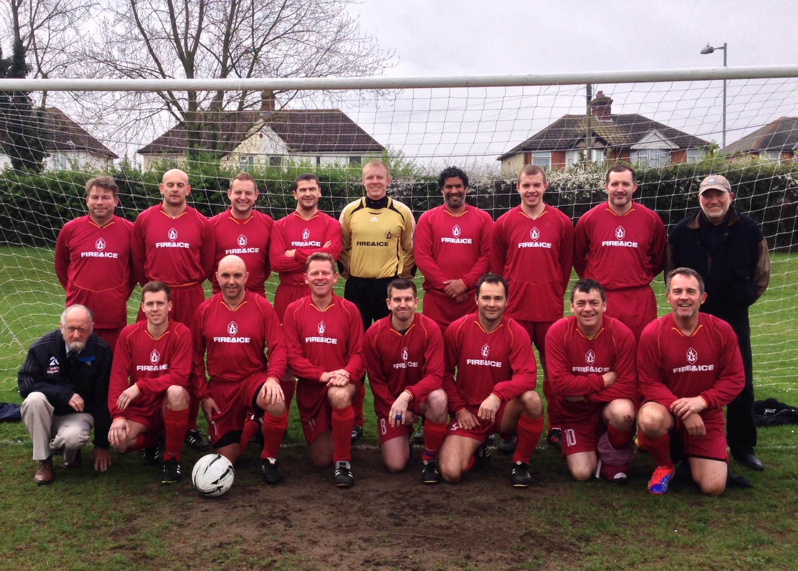

Bevan Burgess (left)

**Taverners FC – a brief history**

Many of our newer players may not know much about the Club’s past, which goes all the way back to 1967 when we entered the (then flourishing) Gippeswyk Sunday League, playing in the afternoons with home matches at Woolverstone.

We switched to mornings in 1972, joining the Ipswich Sunday Morning League and five years later Taverners added a reserve team; we have maintained two teams ever since.

The 1st team played home games at Gippeswyk and Bourne Parks and Gainsborough Sports Centre before moving to Cranes ground in Playford Road (now the ITFC Academy), our home both on Sundays and for training for many years.

The reserves had mainly used Nacton ‘stadium’ and Landseer School prior to both our teams moving to Greshams in 1998 with training switching to Copleston High School.

For 19 years – beginning in the mid-eighties – the big highlight of a Taverners season would be the Easter trip to Belgium to play in an annual tournament.

Veterans of those weekends continue to chew over some great times and there should still be a few copies of the DVDs of latter years available to provide a smile or two.

Particular high-points on the playing front over the years have been the 1st team winning Division 2 of the Sunday Morning League in 1994 and the reserve team lifting the League Reserve Cup a year later.

And we can boast some loyal clubmen:

* Taverners Chairman Pat Elvin made 721 appearances for the Club;
* Of our current players, Bevan Burgess, Gary Cunningham & Daren Stevens have played over 600 matches; and
* James Bullamore, Trevor Hollinsworth, Gary Pilkington and Duncan Southgate have 400 plus games to their credit.

A full history – decade by decade in detail – appears on the Club website: www.tavernersfc.org.uk

**Training**

Training resumes at Copleston Sports Centre on Thursday 8 January 2015 at 8pm.

**Daren nets his 150th Taverners goal!**

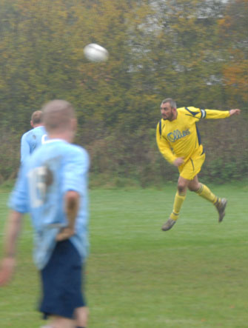

**The 1st team’s first match against Bucklesham saw Daren Stevens score his 150th goal for the Club.**

**While the photo above is a typical action-shot of Daren, his 150th was more spectacular – a diving far-post header to score from Jawa Tacey’s free-kick.**

**Daren now stands in fourth place in the Tavs’ all-time scoring list – behind Trevor Hollinsworth (235), Gary Cunningham (224) and Pat Elvin (172).**

**We wish all Taverners members and supporters and their families all the best at Christmas and a Happy New Year!**

